Data management: we will be focussing on the dimension part of the data.

Source: SuperStoreCanada

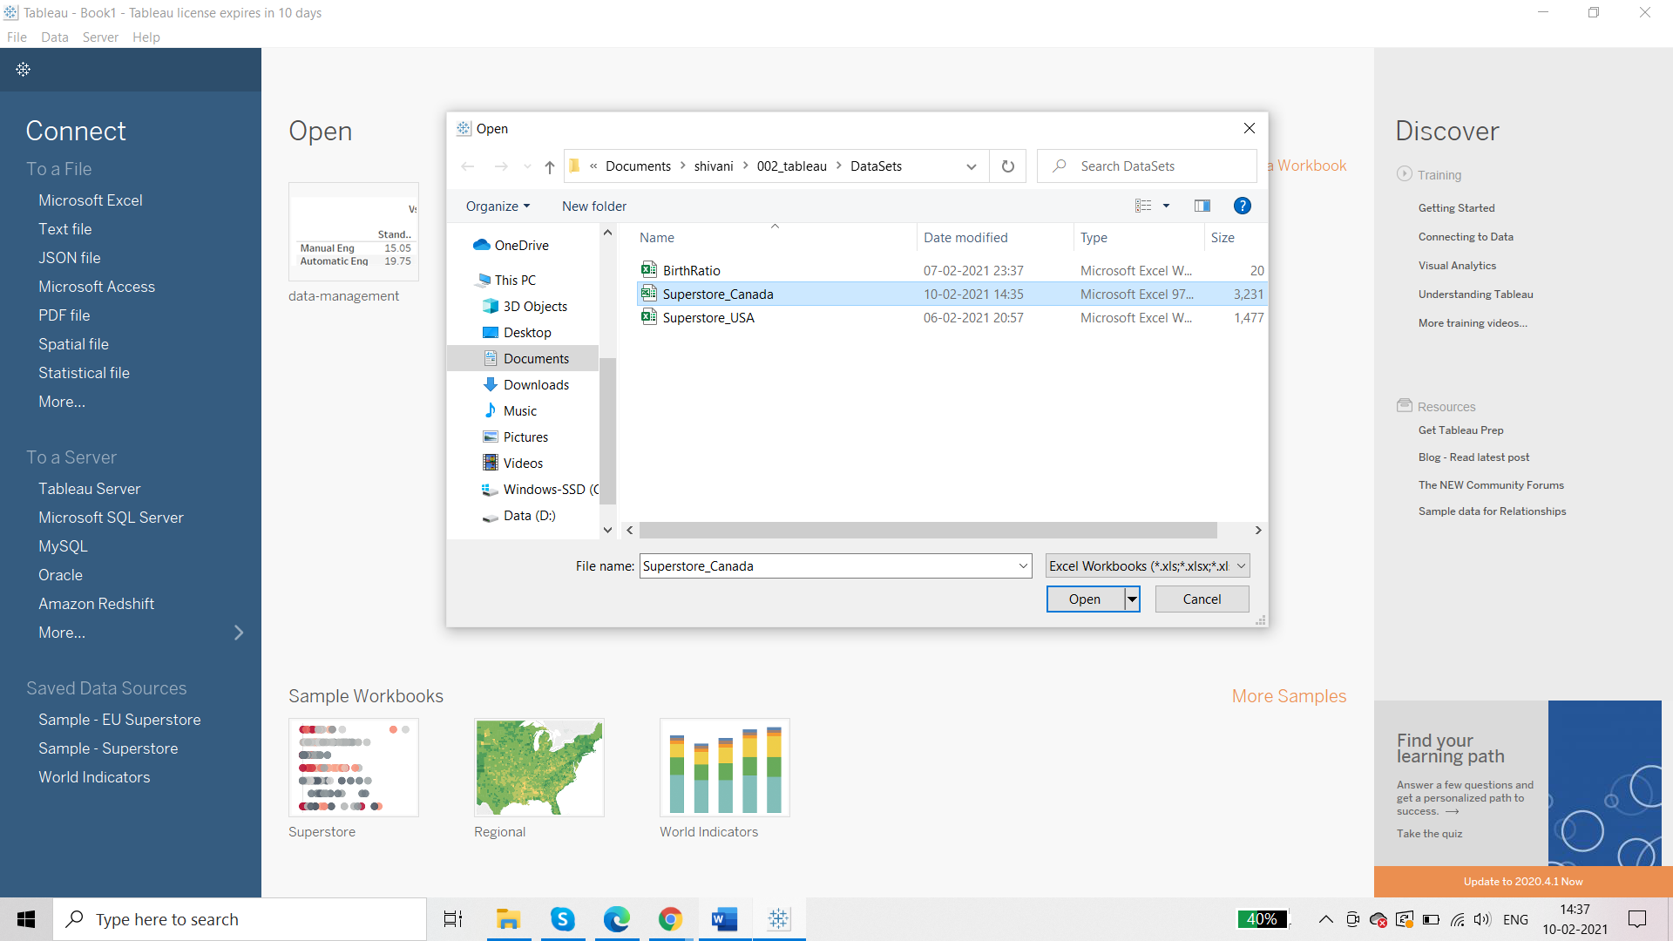

**Basic Filter**

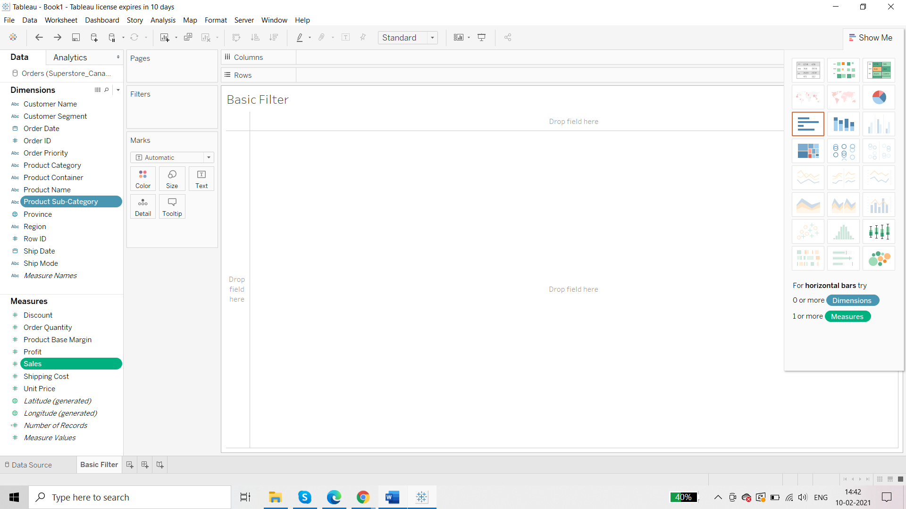

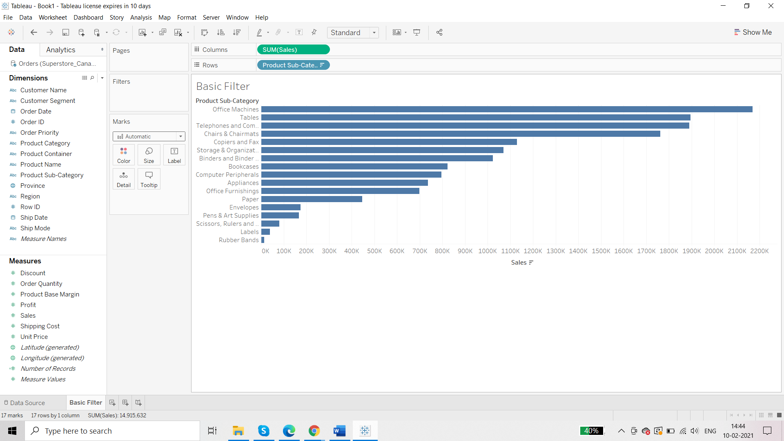

**Requirement: We want to apply filter as per the product sub category**

Click on the dimension pill that you want as filter 🡪 show filter then you are going to see the pill in Filters shelf and checkboxes too (Filter Pane)

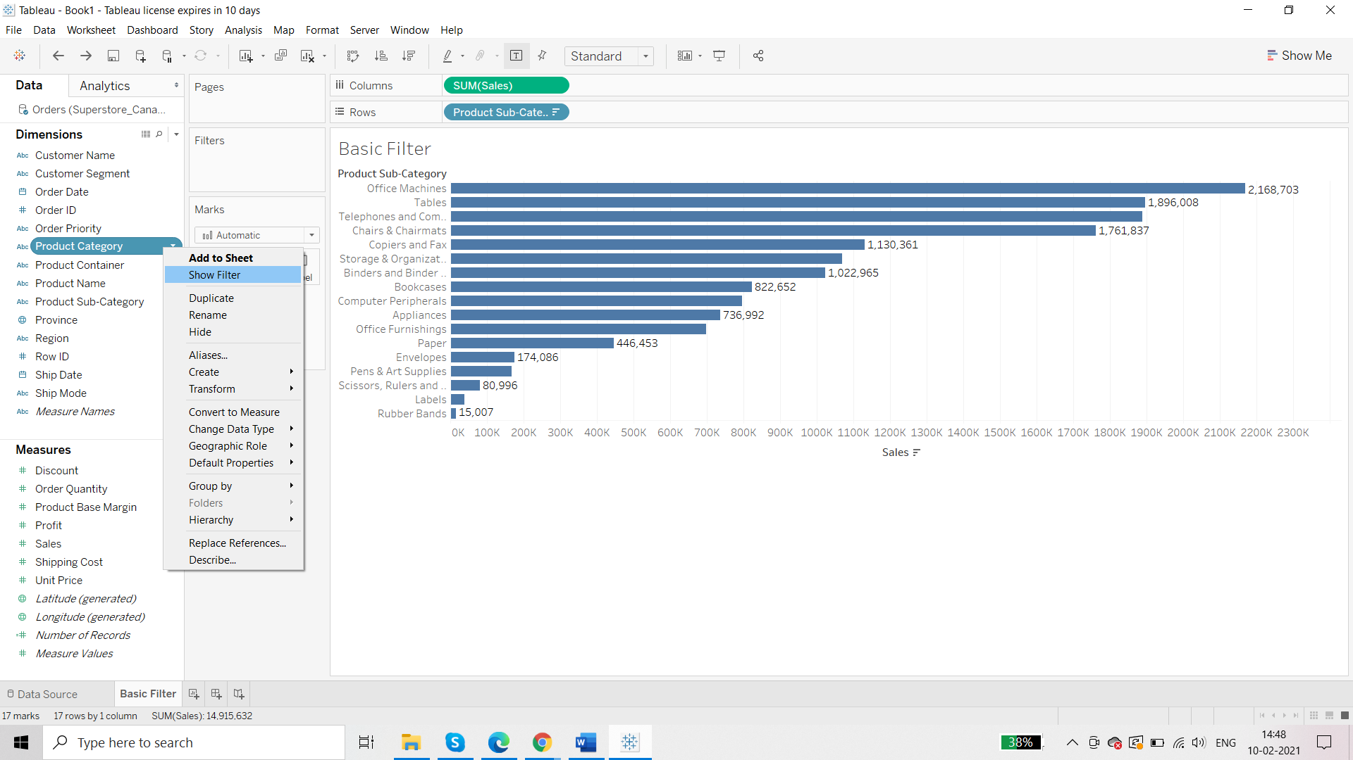

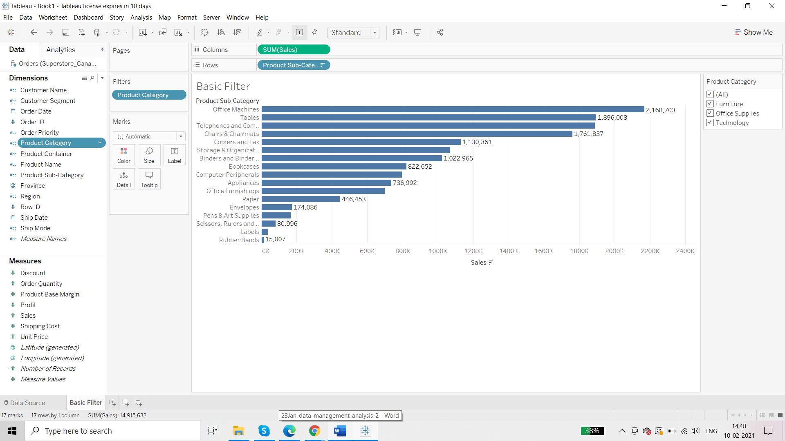

There are various options to display this filter pane:

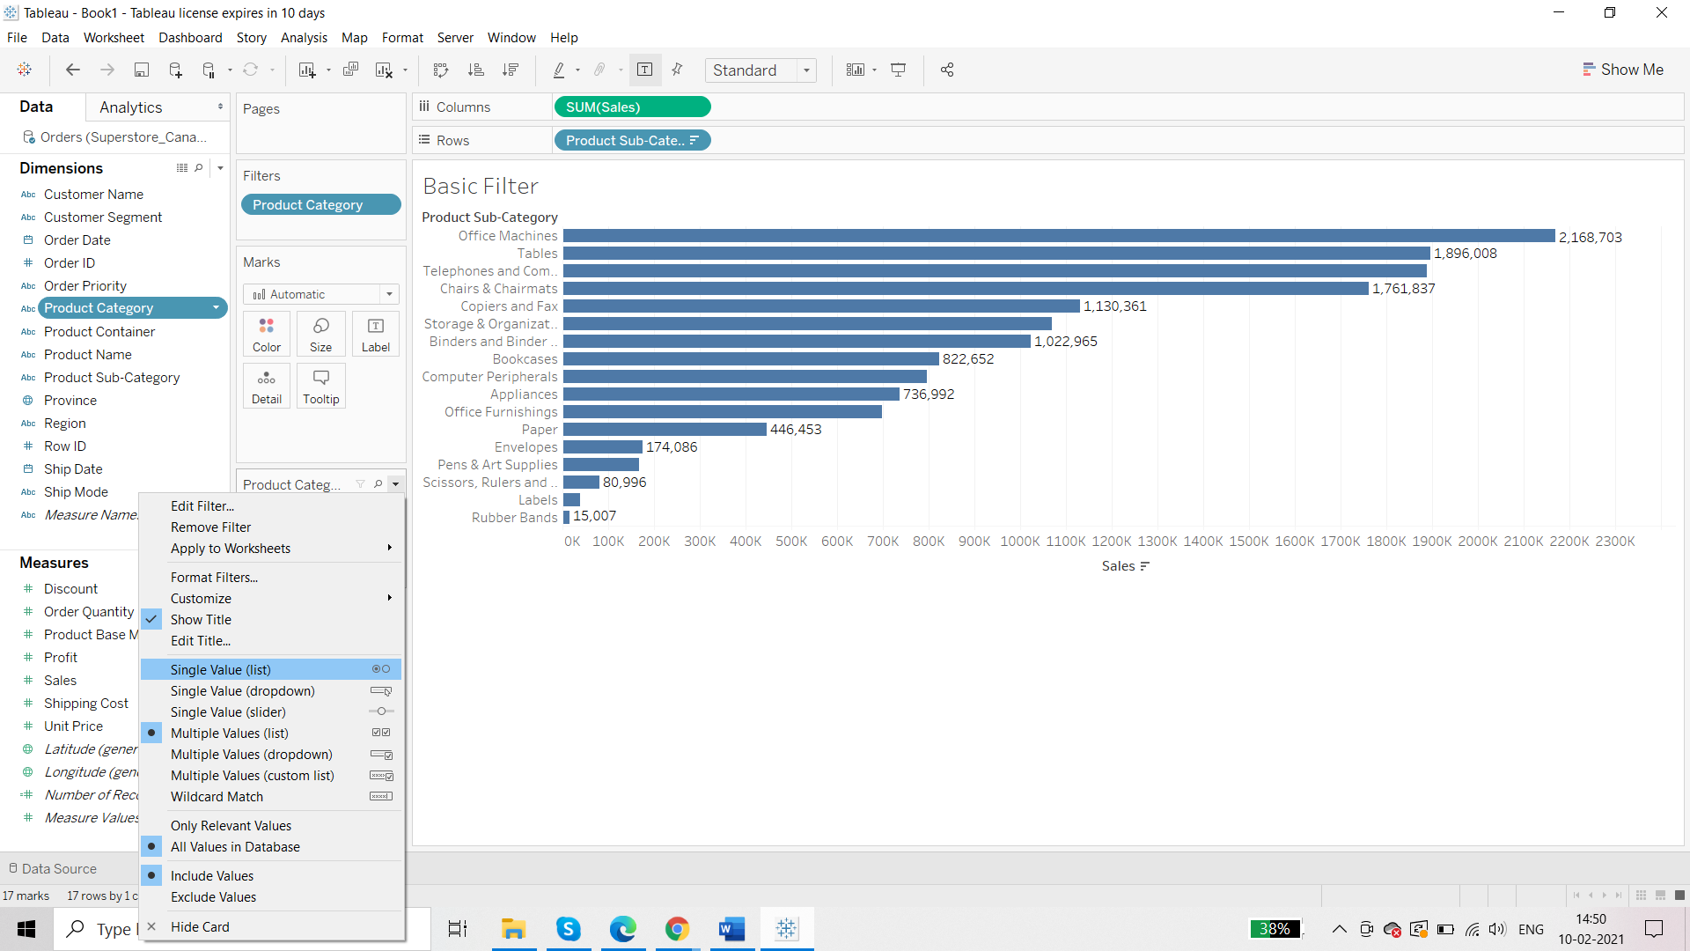

Single Value (list)

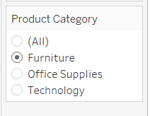

Single Value (dropdown)

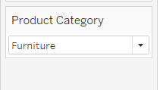

And so on.

There are customizable options too:

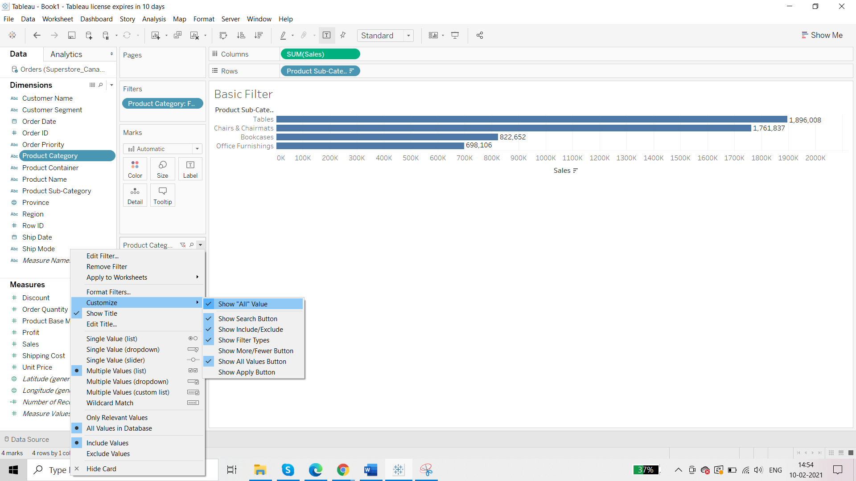

**Multiple Filters:**

Product Sub-Category is also added:

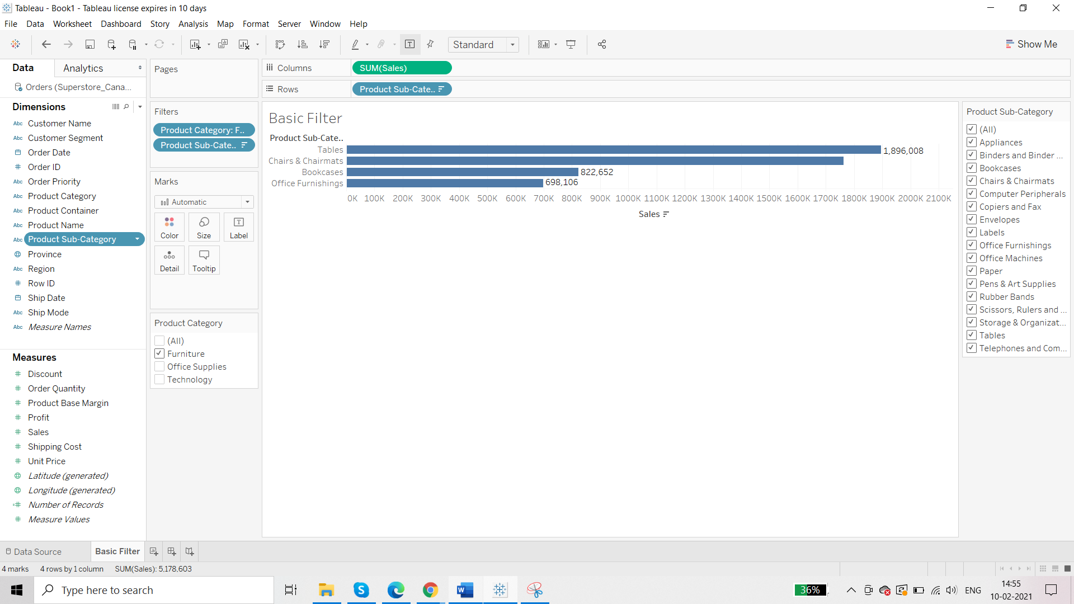

But you will notice that the second filter i.e. Product Sub Category is not in sync with original filter. So right click on the Product Sub Category 🡪 Only relevant values

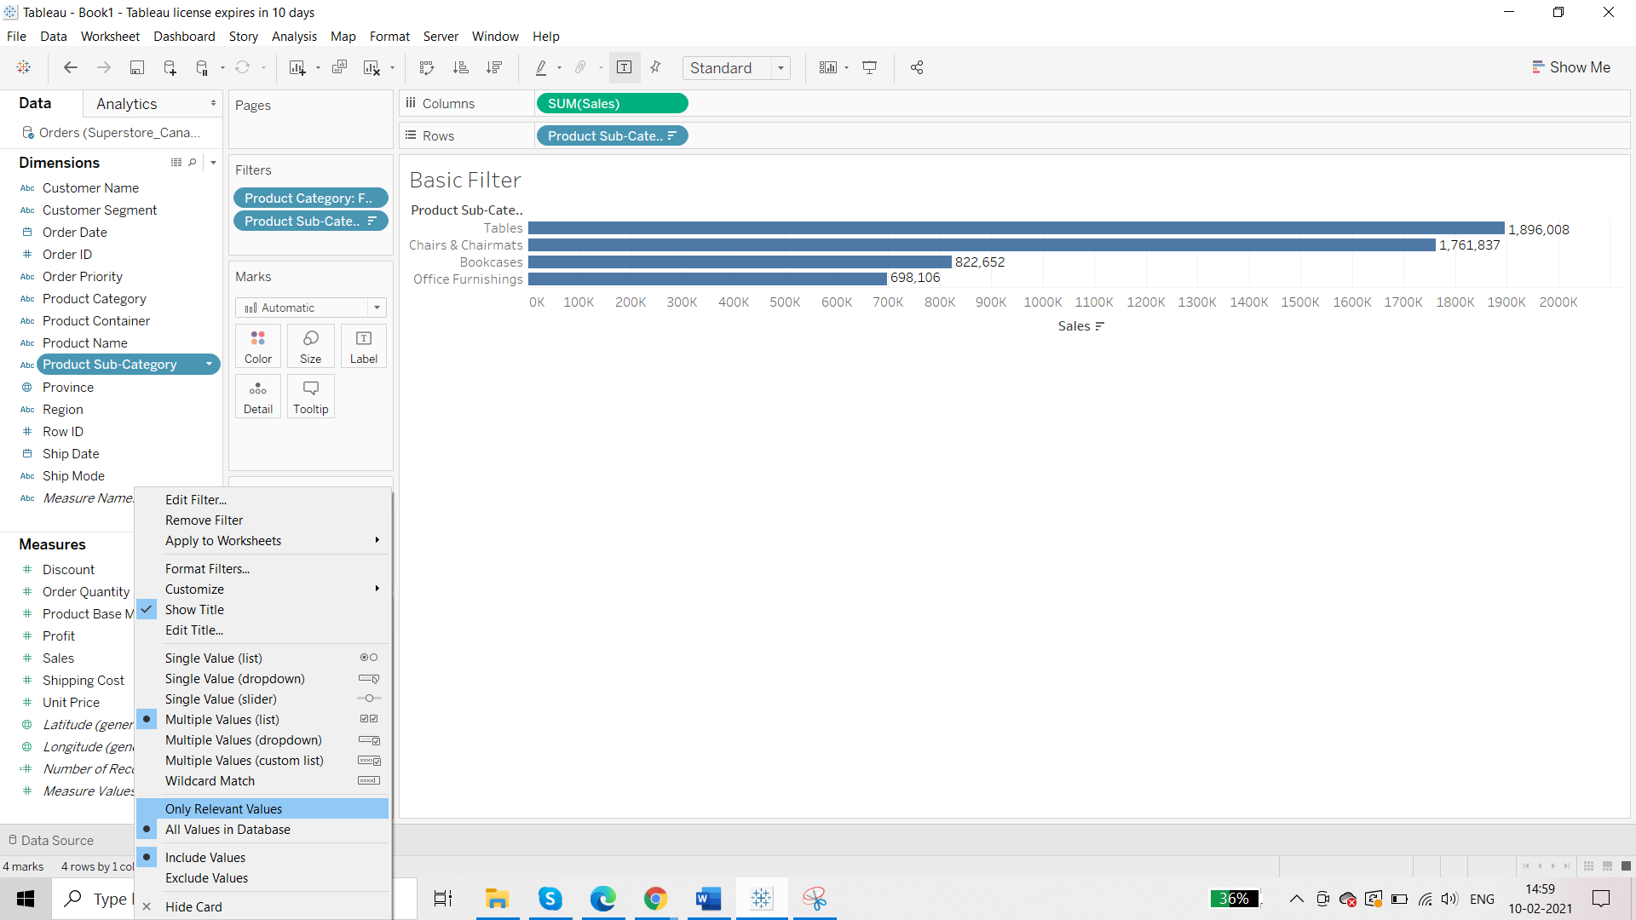

Previously:

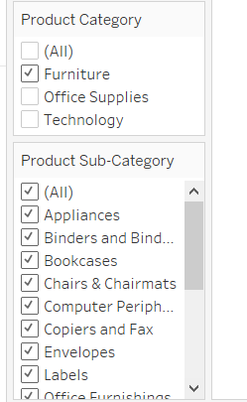

Now:

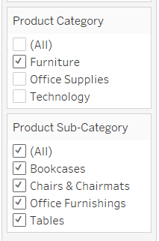

We had to sync Product SubCategory with Product Category because we had missed most important step of data preparation which is identifying the hierarchy.

Now remove the filters and apply the hierarchy and then apply the filters.

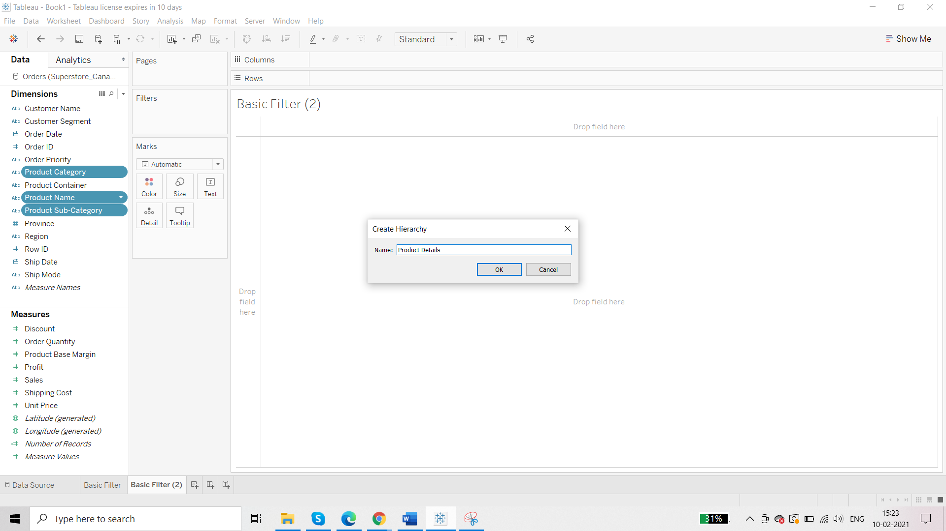

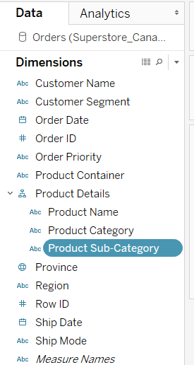

Now create the same visual:

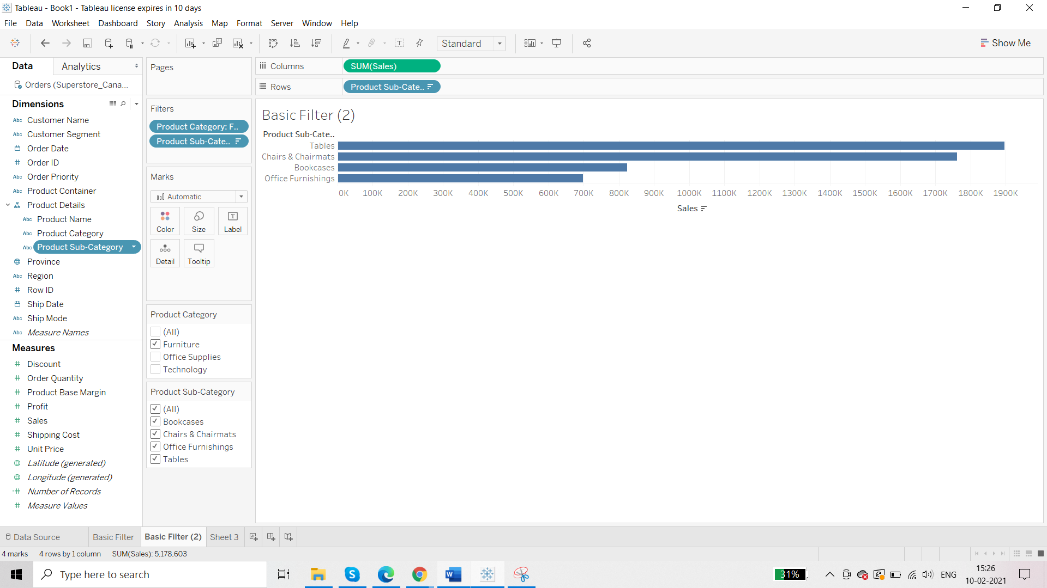

**Admin Filter**

**Requirement: admin filter is used when we want to filter the data but do not want to give this filtering option to the end user**

For example: we want to display product sub category vs sales and profit. We want only “office supplies’’ but there should be no Filter Pane.

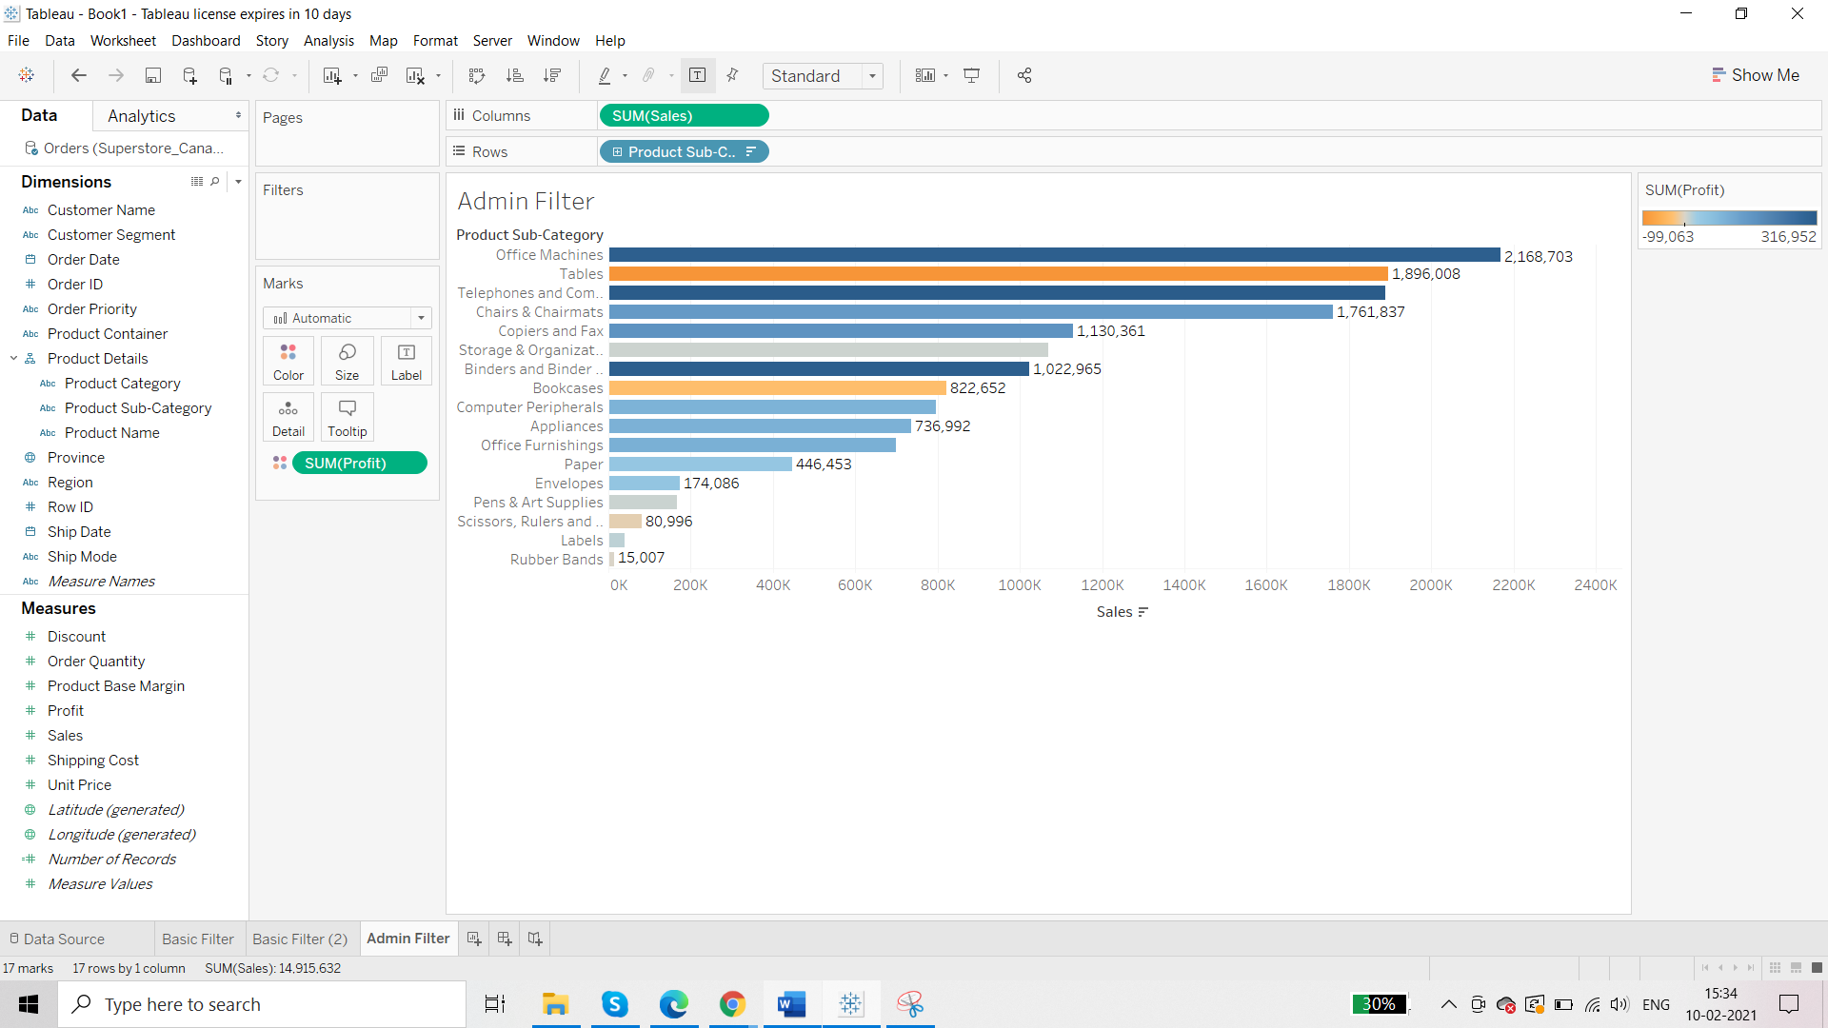

Now drag and drop the Product Category to the Filter Shelf:

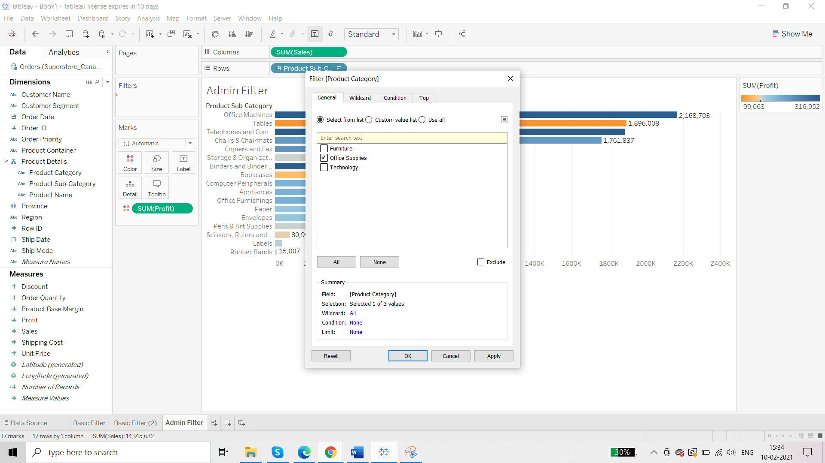

Click on ‘Office Supply’

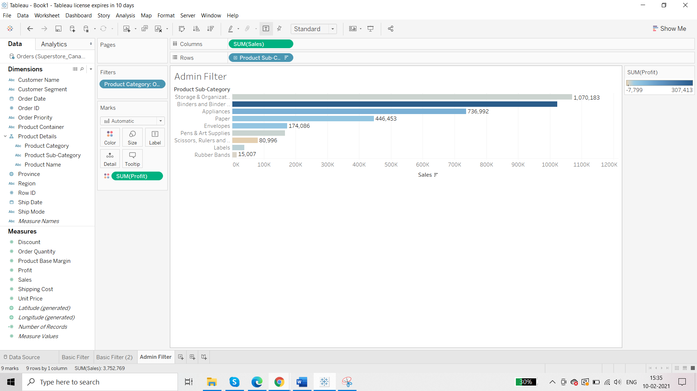

Reading view:

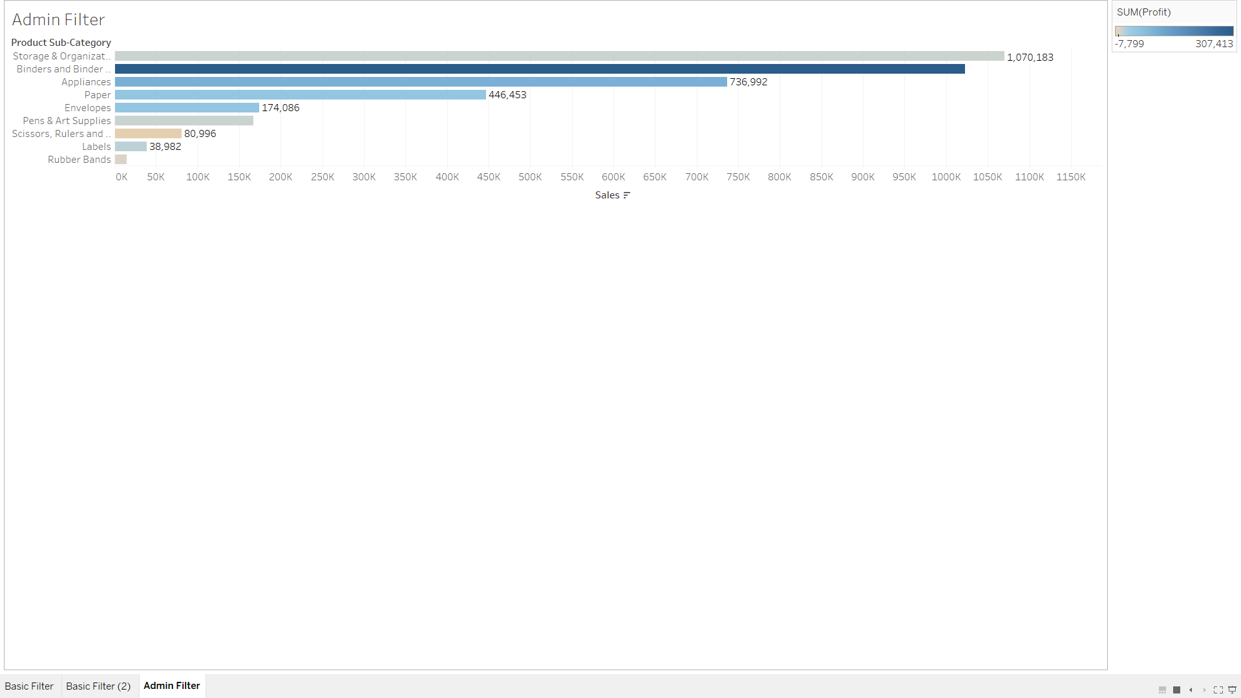

End user has no option to apply filters.

Using dimension as a title:

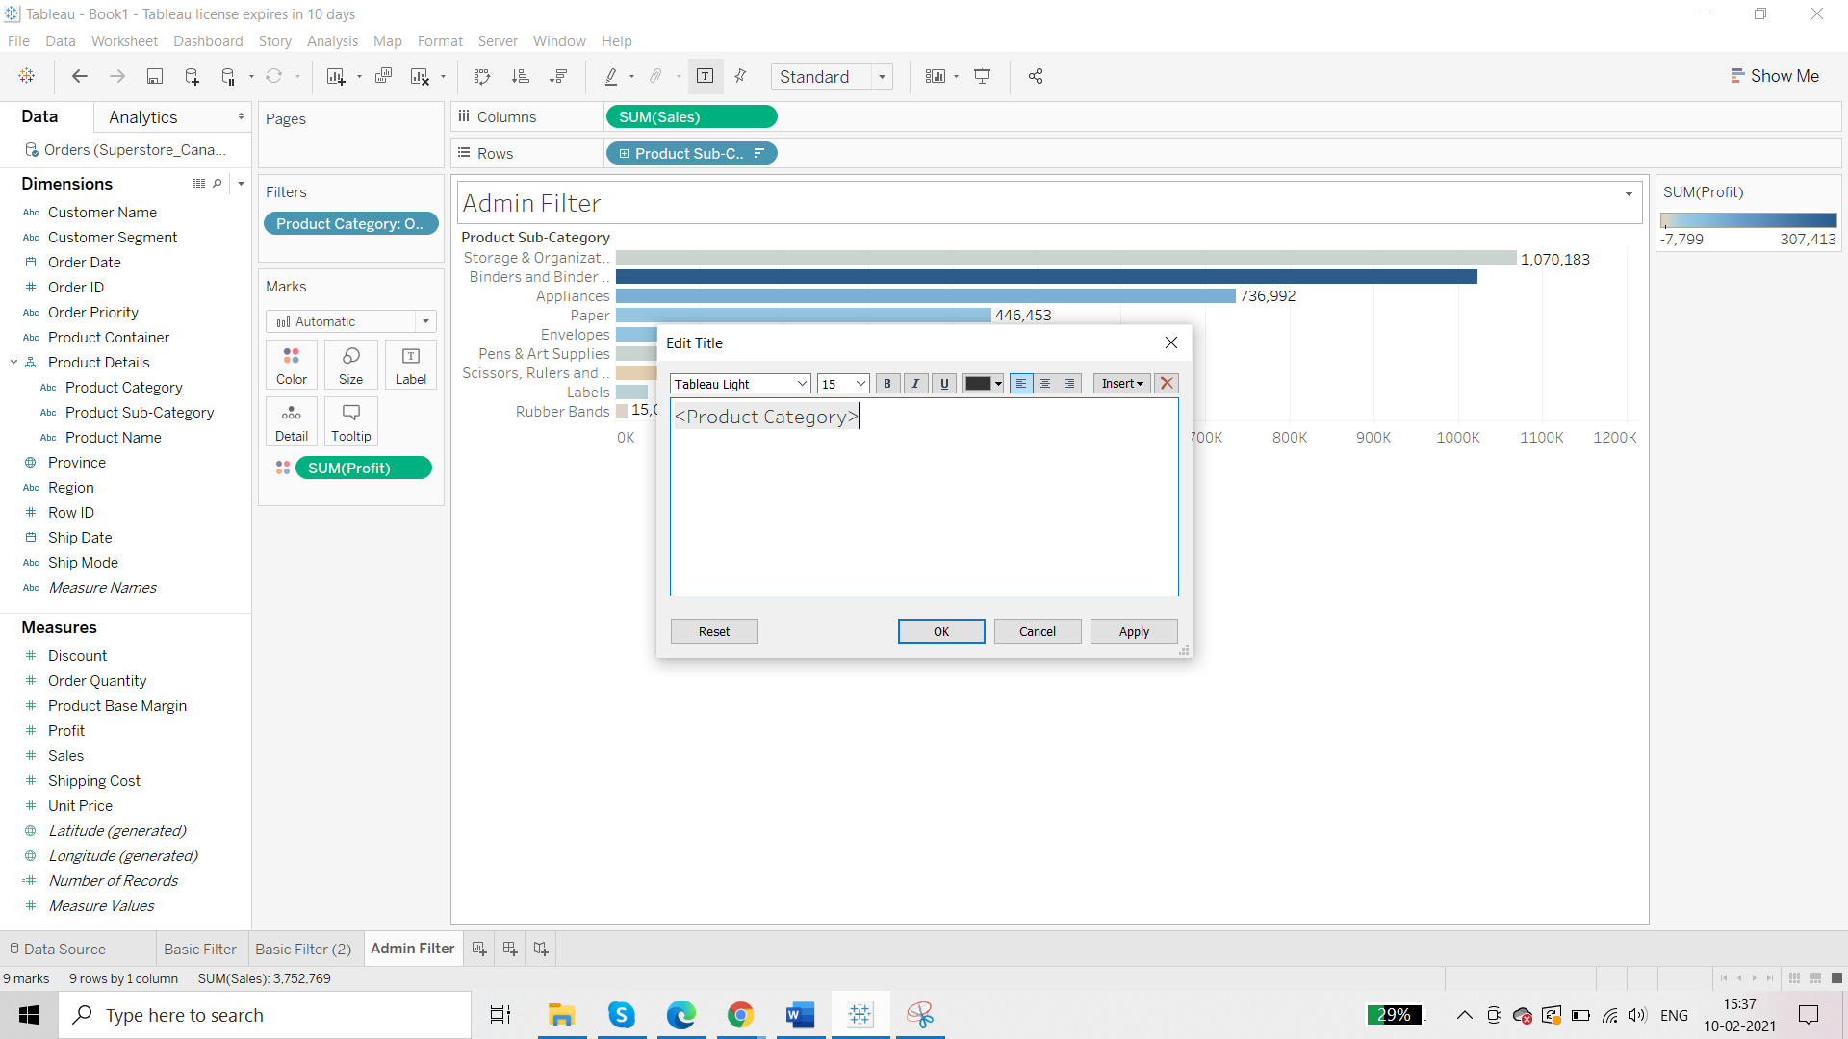

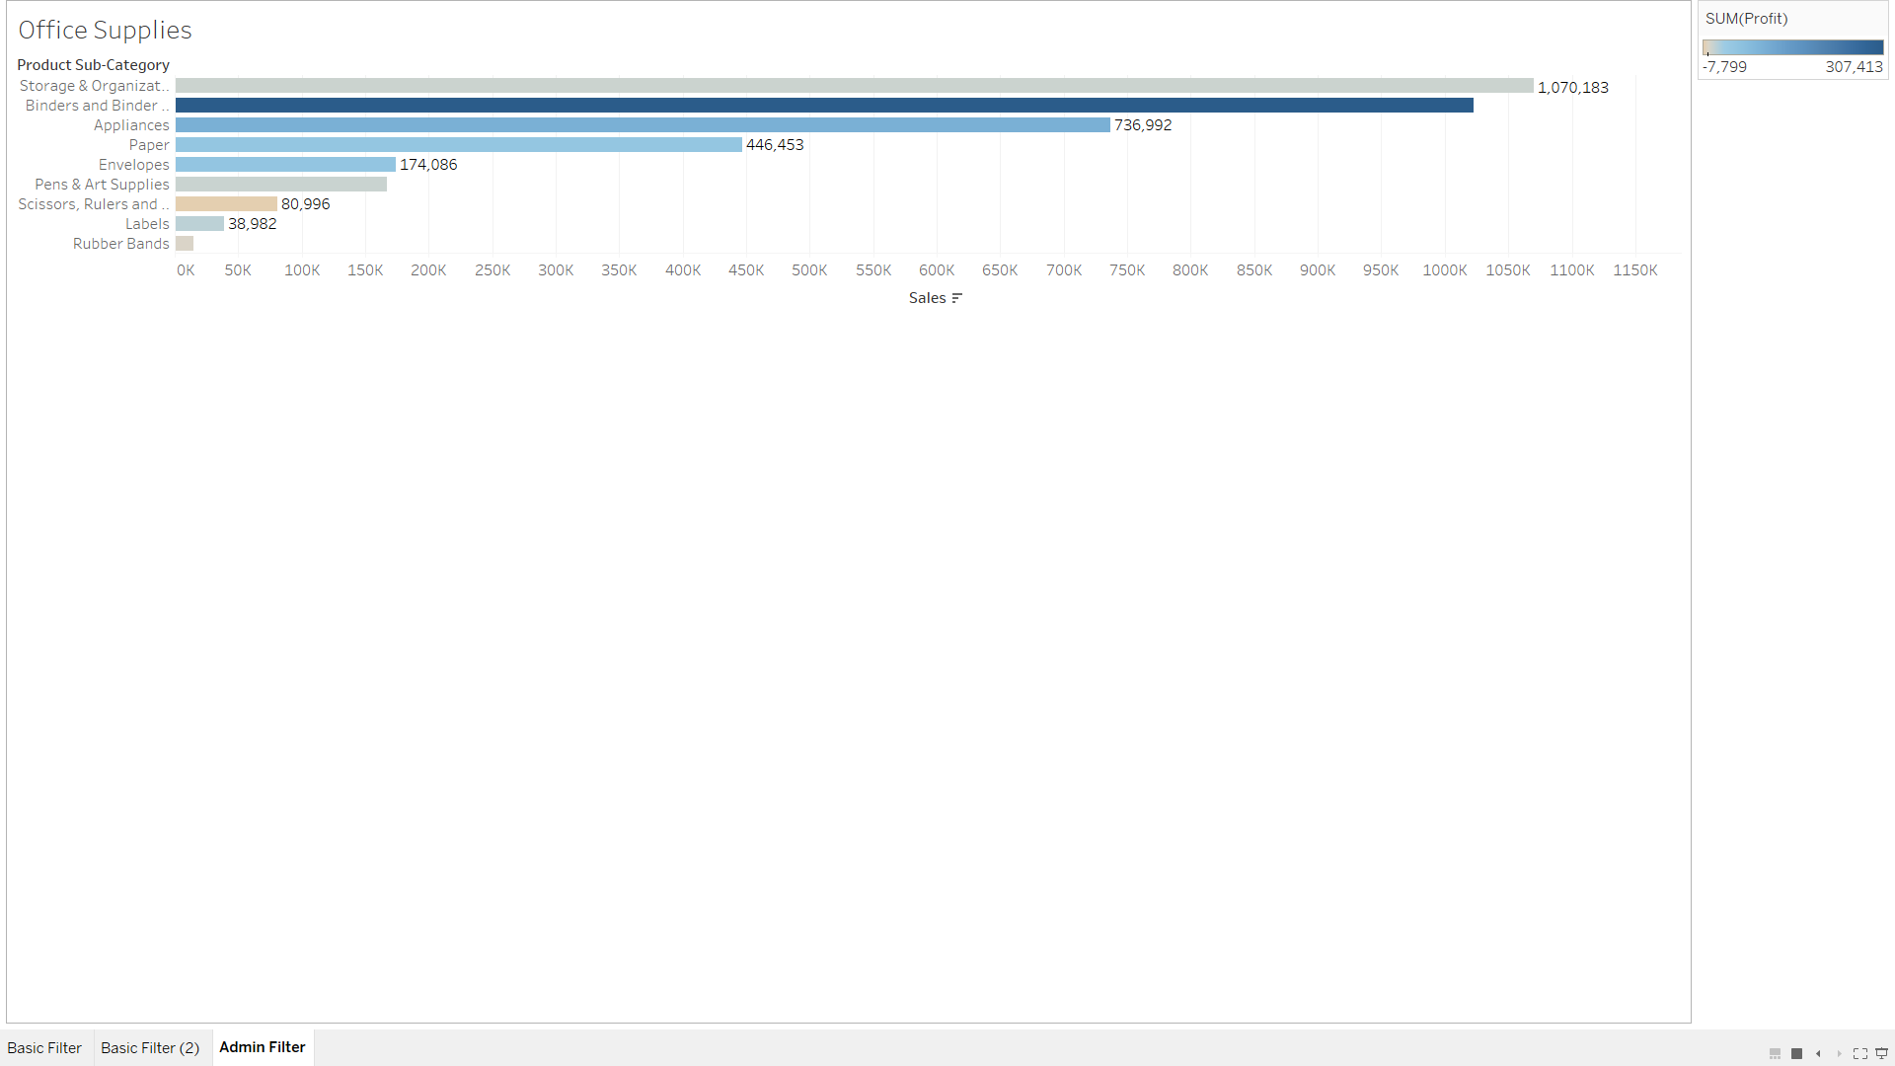

Include/ Exclude Filter:

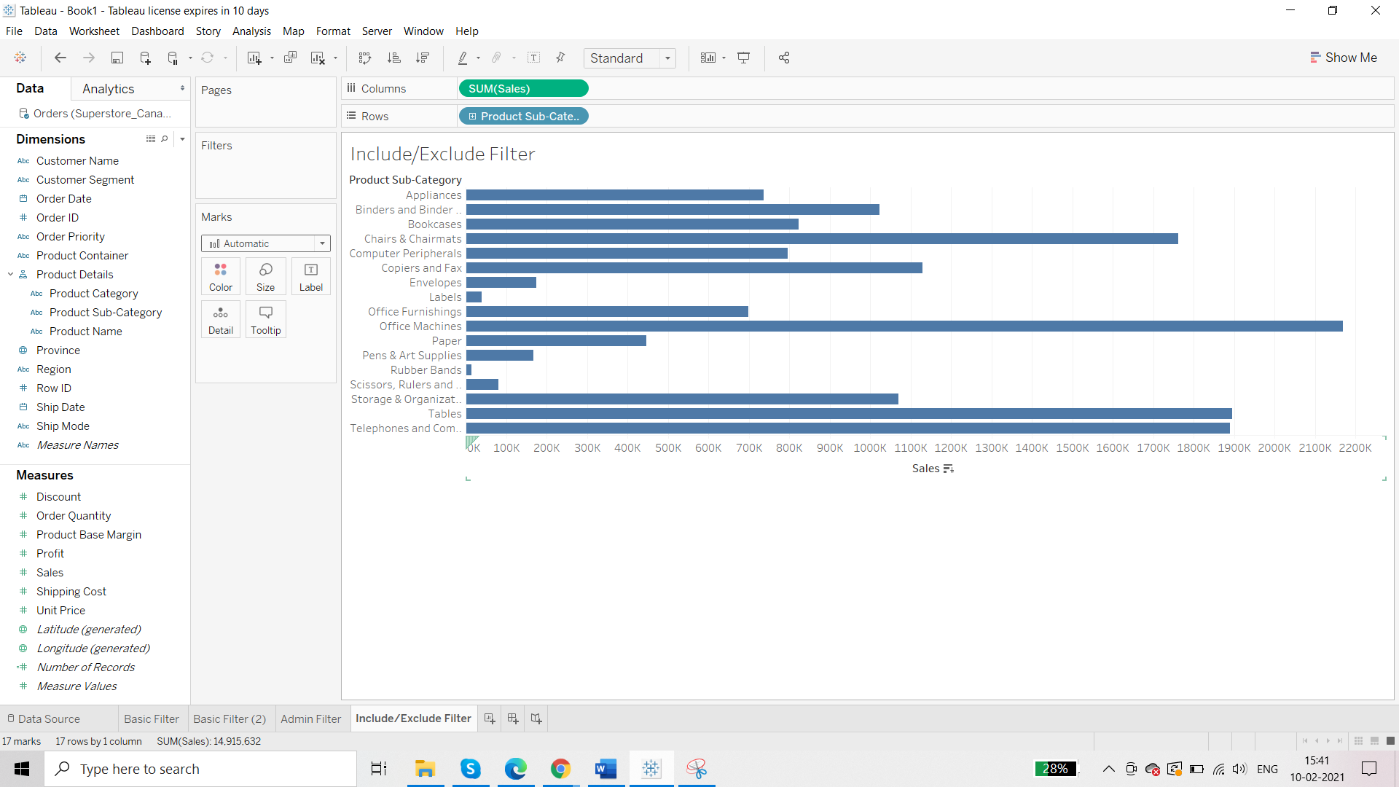

Drag and drop ‘Product Category’ in Filter shelf:

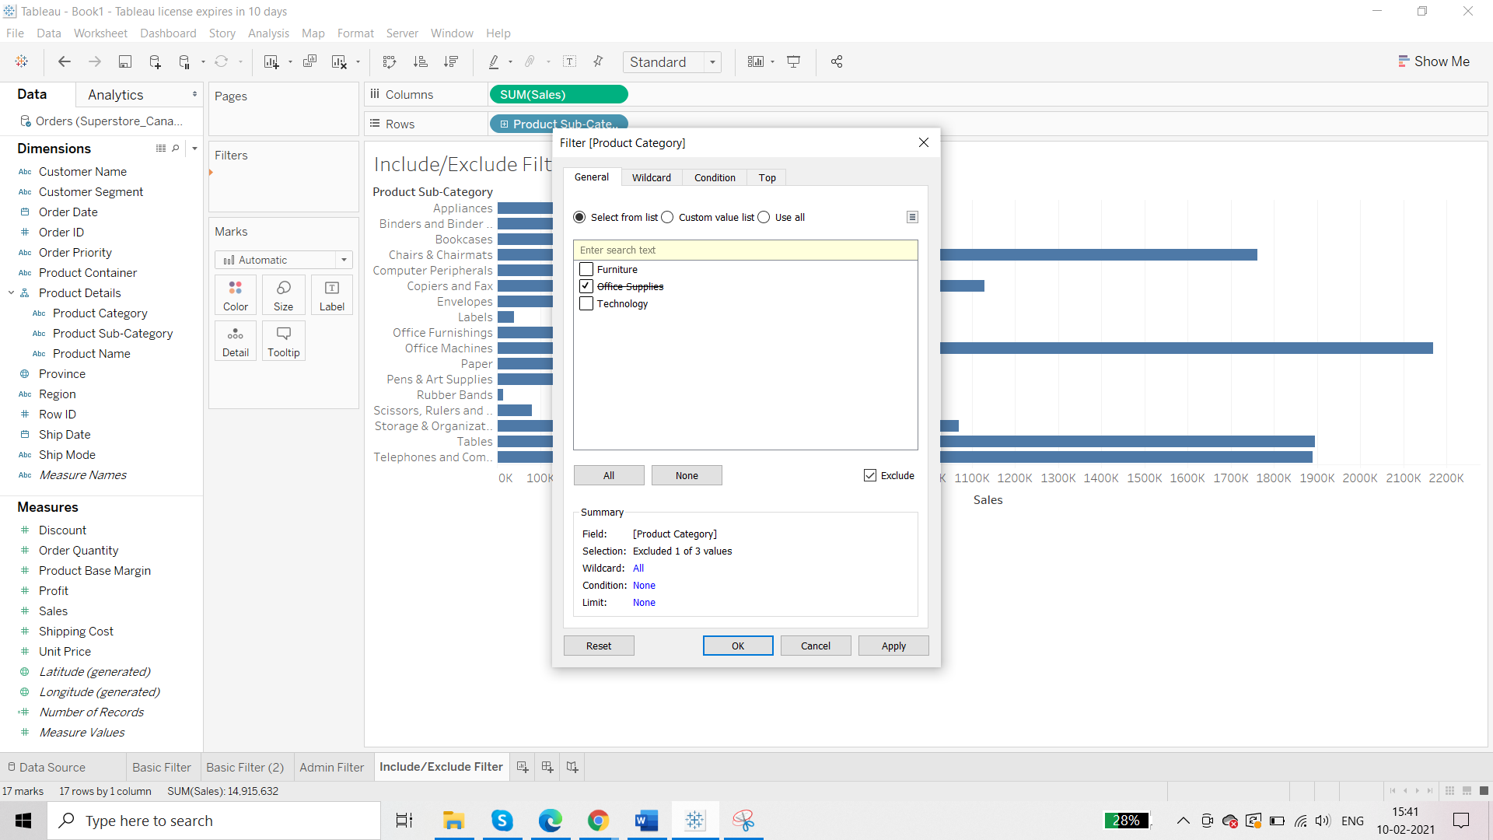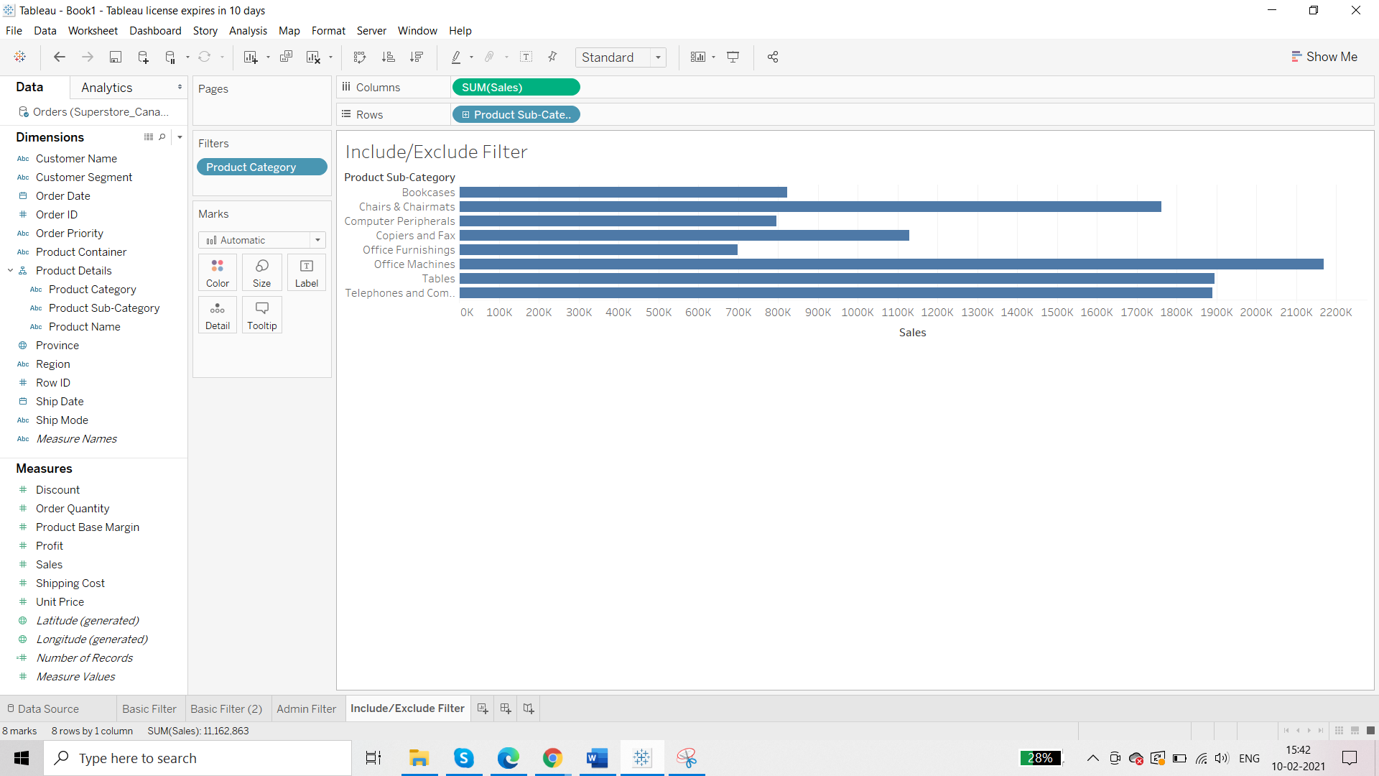

**Wildcard**

**Requirement: we want product related with printer so we use wildcard filter**

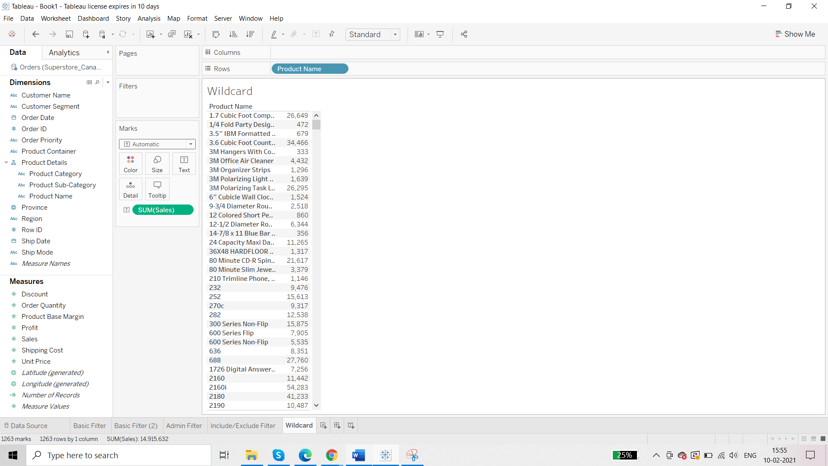

Drag and drop the ‘Product Name’ on the Filter shelf:

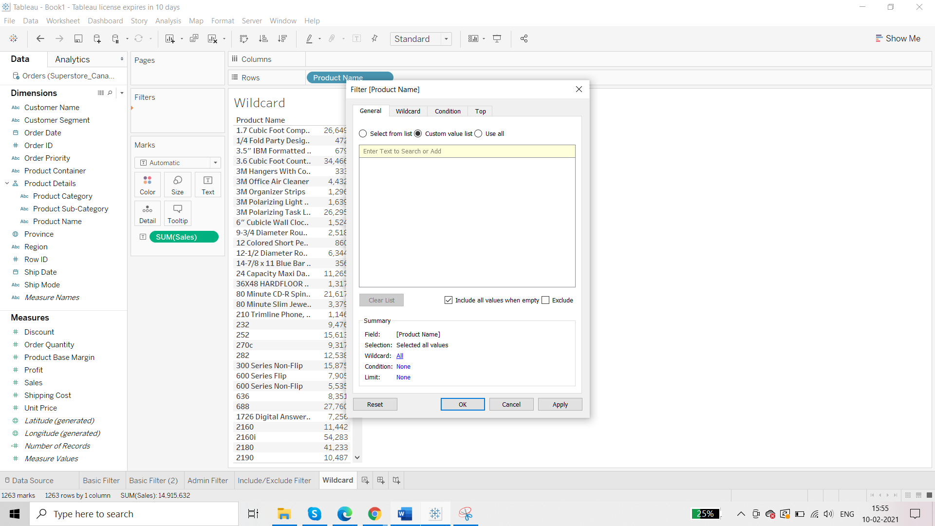

Go to Wildcard tab :

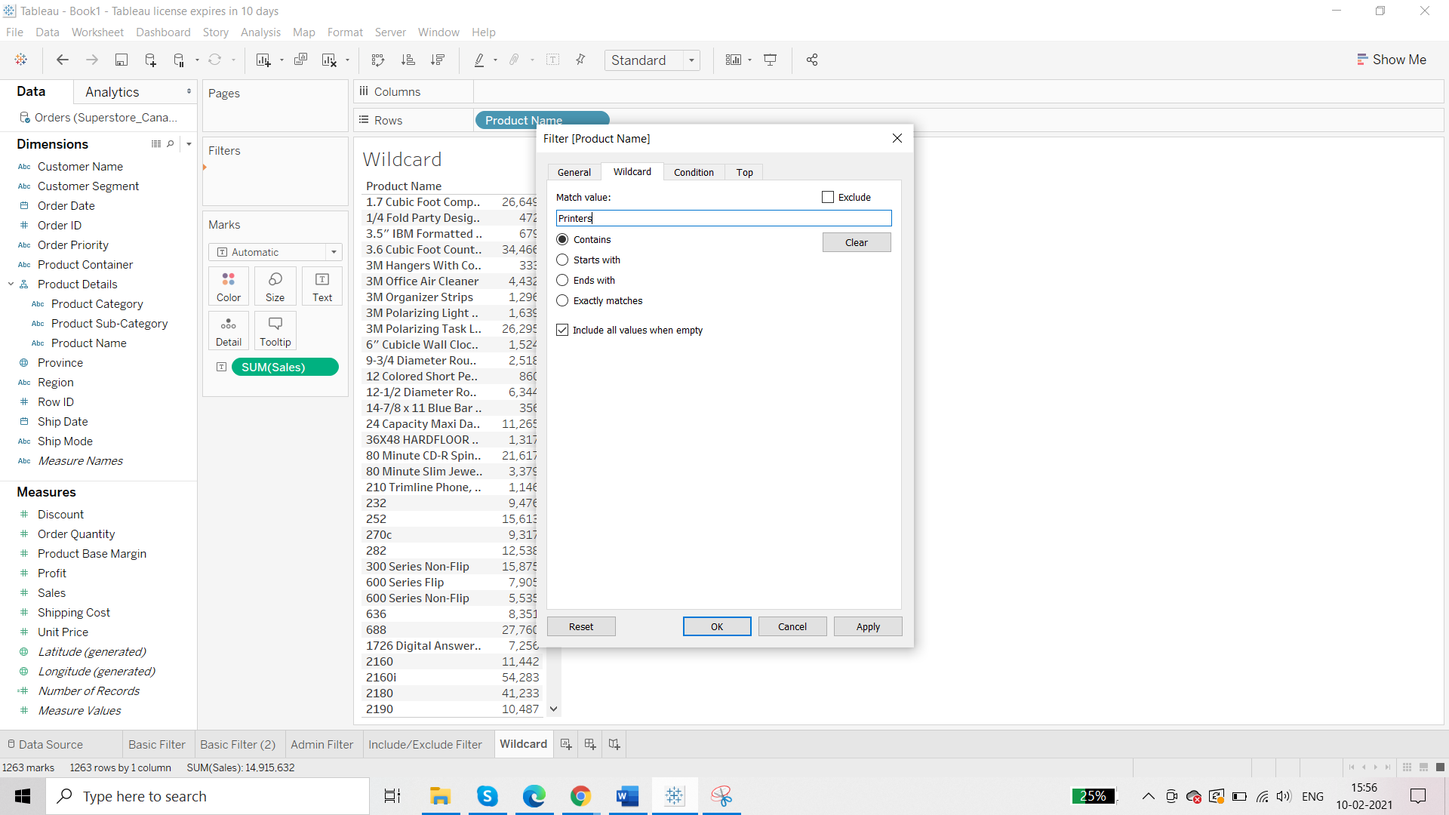Result:

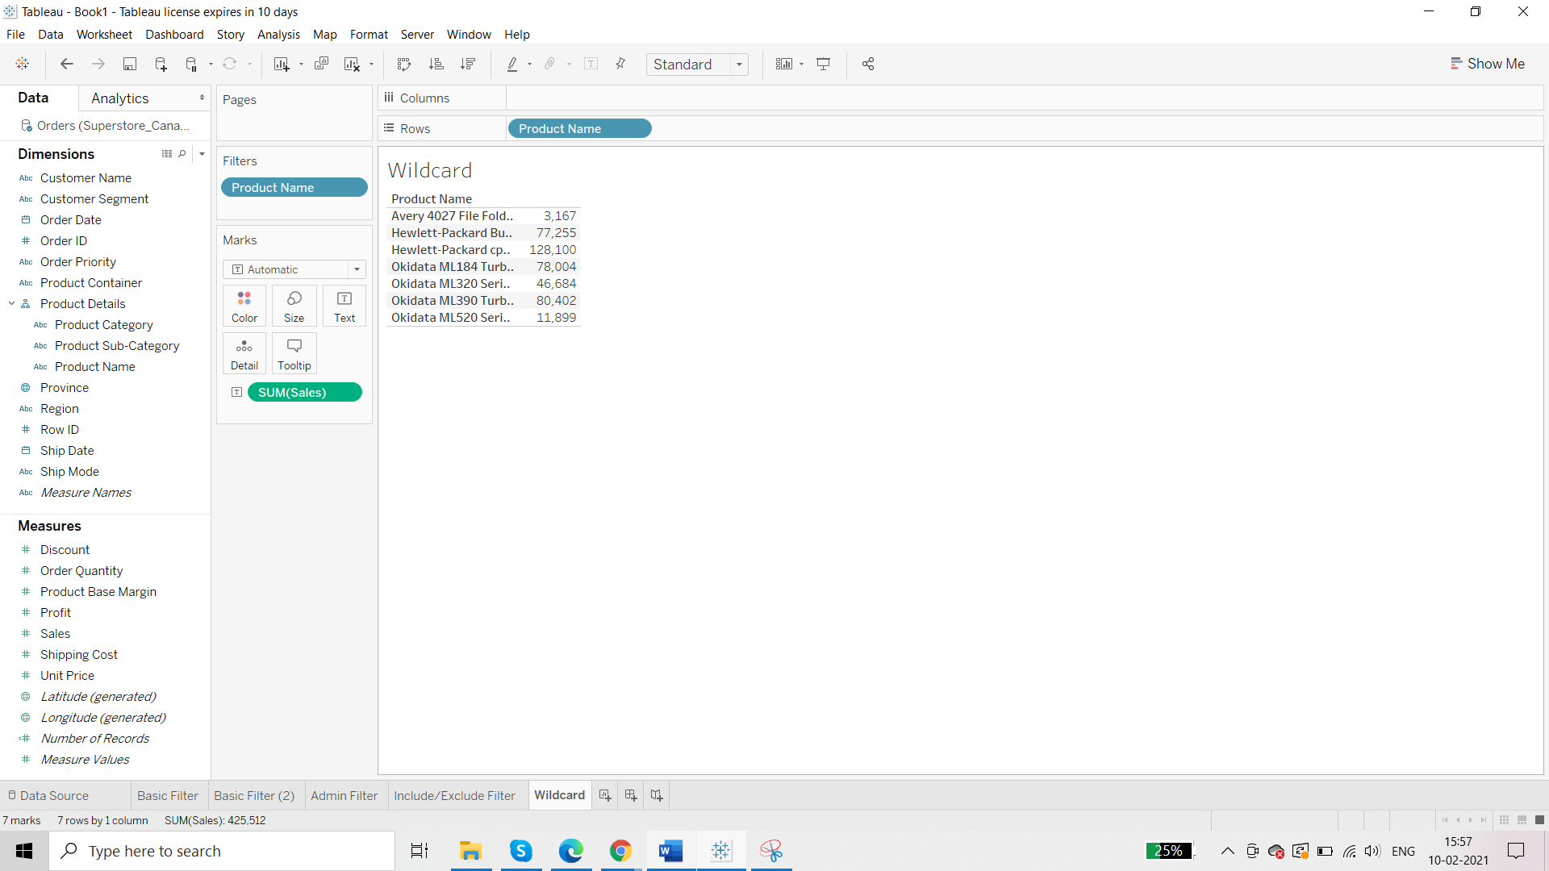

**Visual Level Filter:**

Requirement: relationship between sales and profit in terms of order id

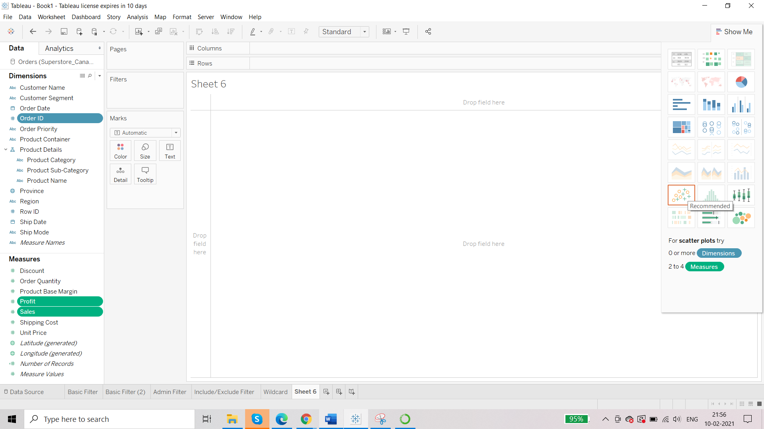

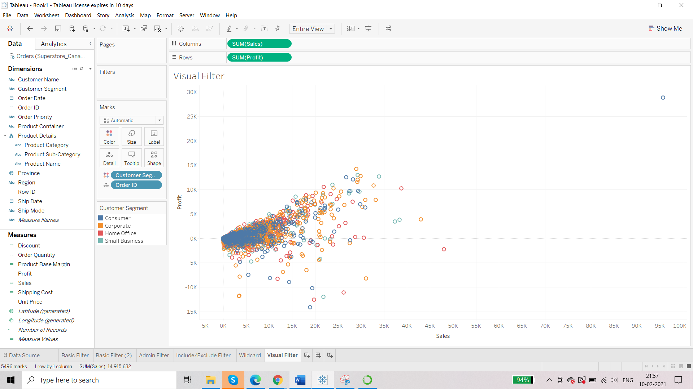

We can exclude the outlier:

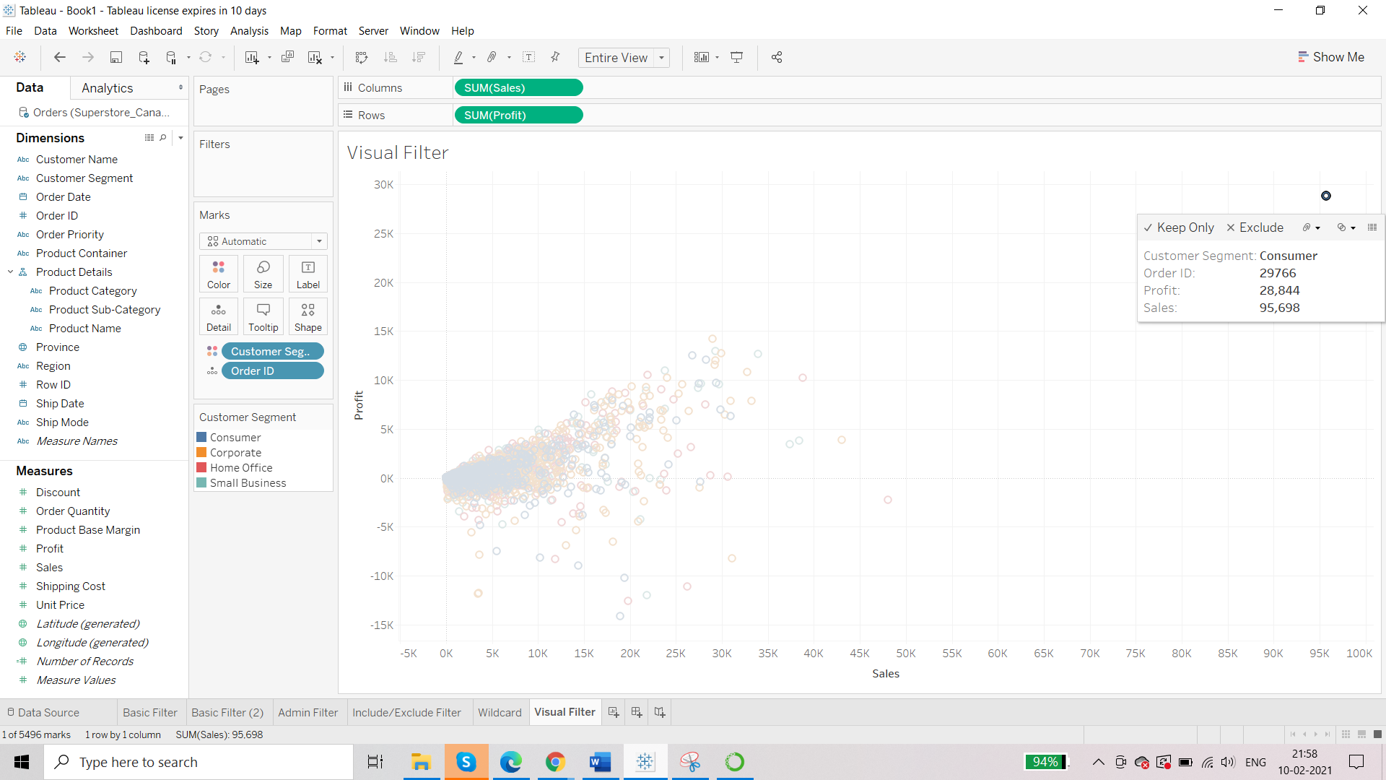Result:

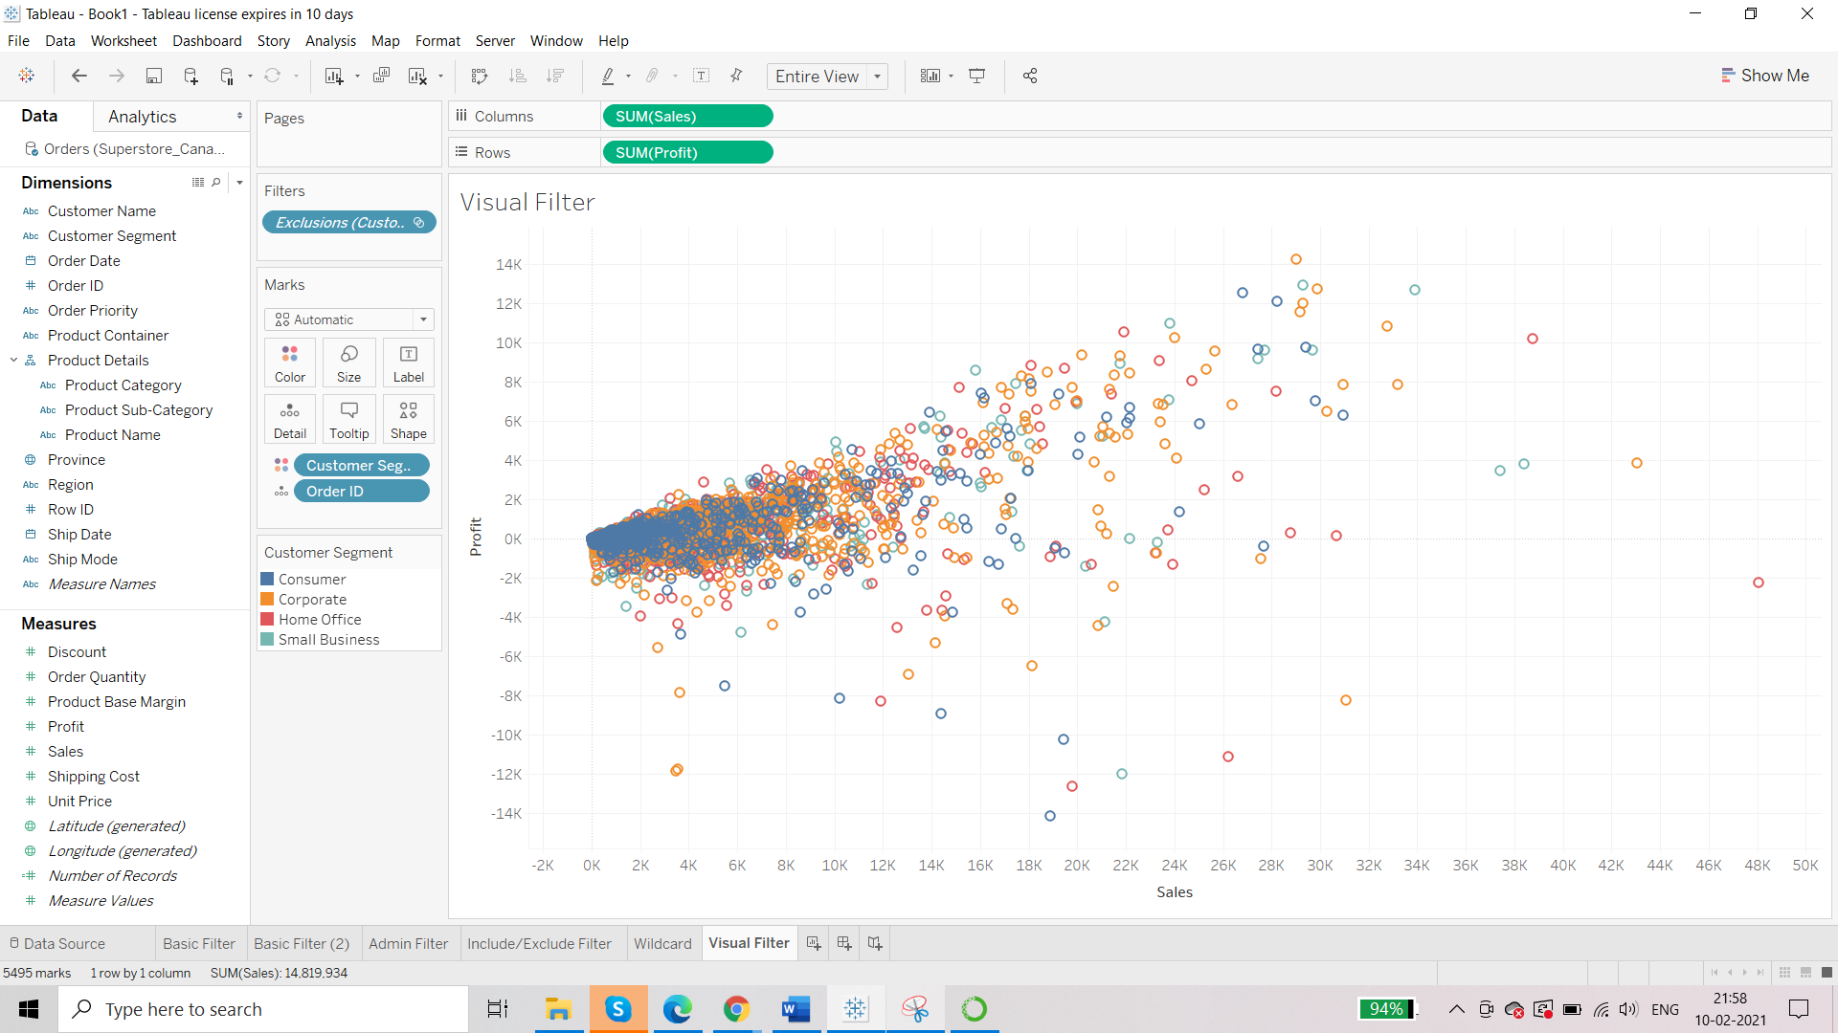

We can focus on a particular area of the report by using Visual Level Filter:

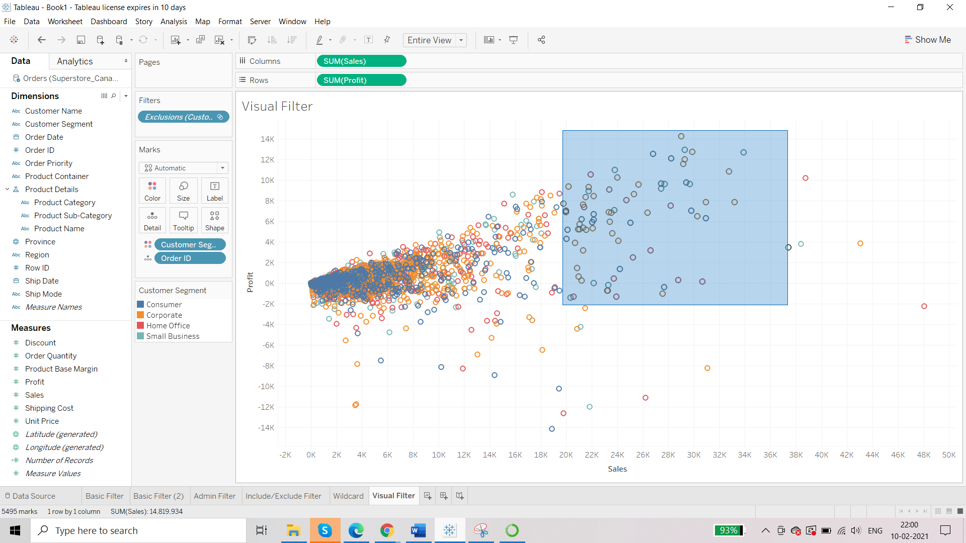

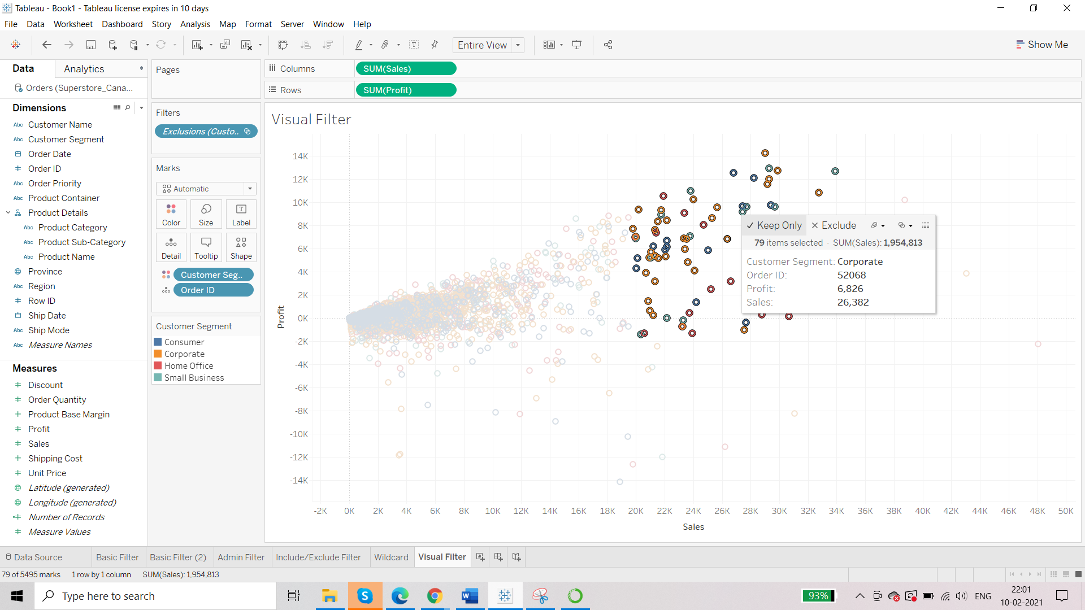

Result:

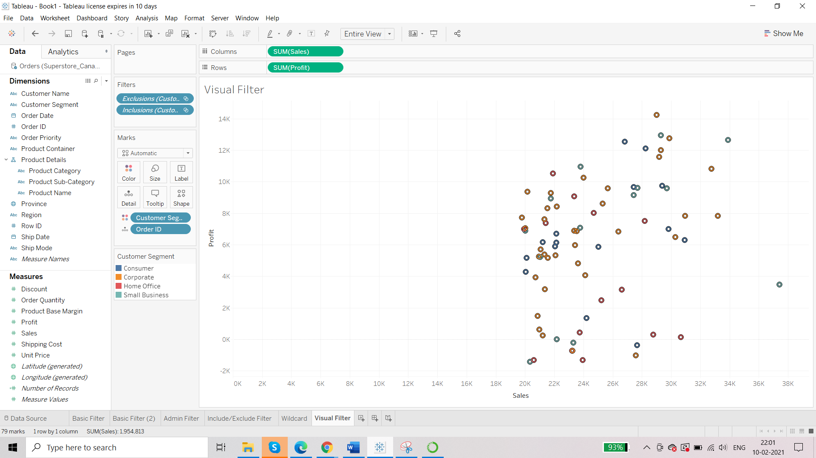

TOP 5

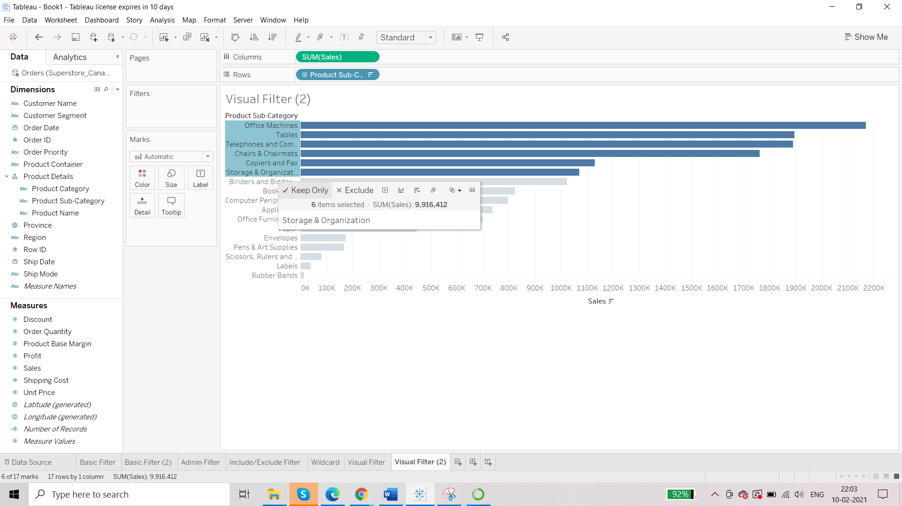 Select ‘Office Machine’ and holding down shift key go to ‘Storage & Organization’

Select ‘Keep Only’

Result:

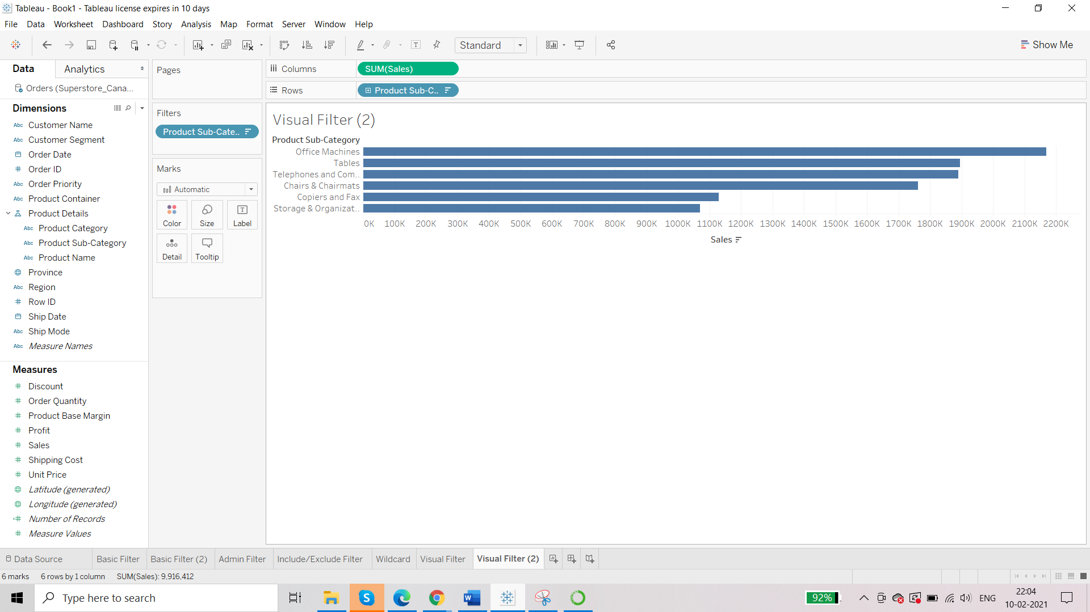

Date Filter

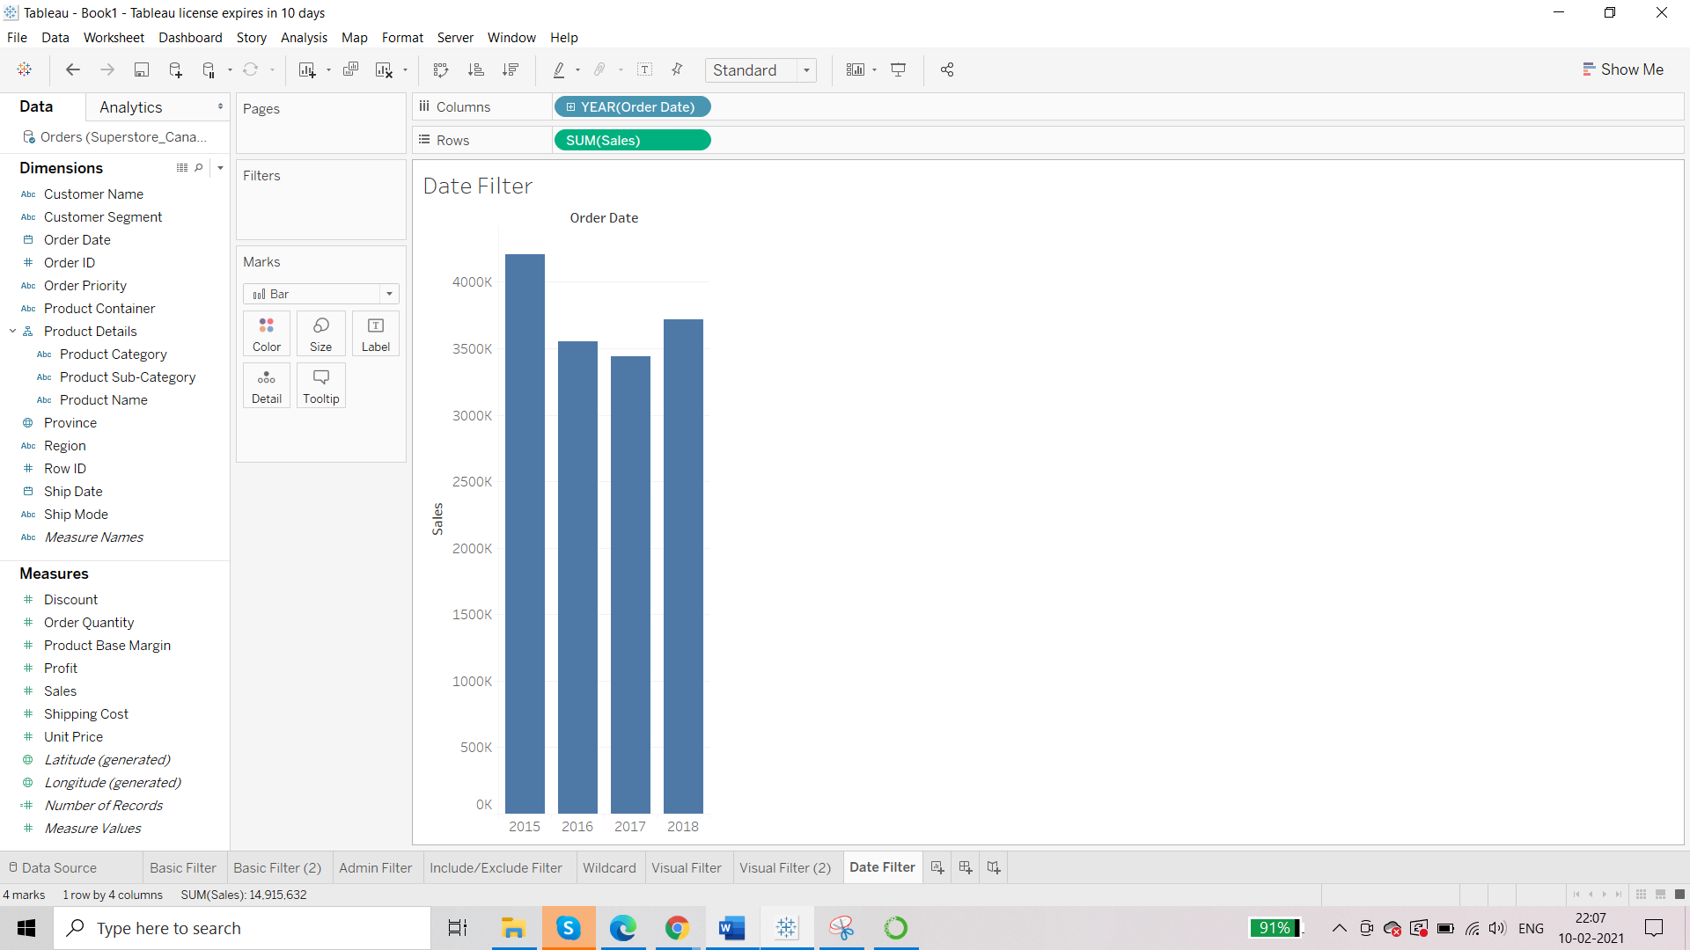

**Requirement: we want to know sales for first quarter for every year**

Approach 1: use ‘keep only’

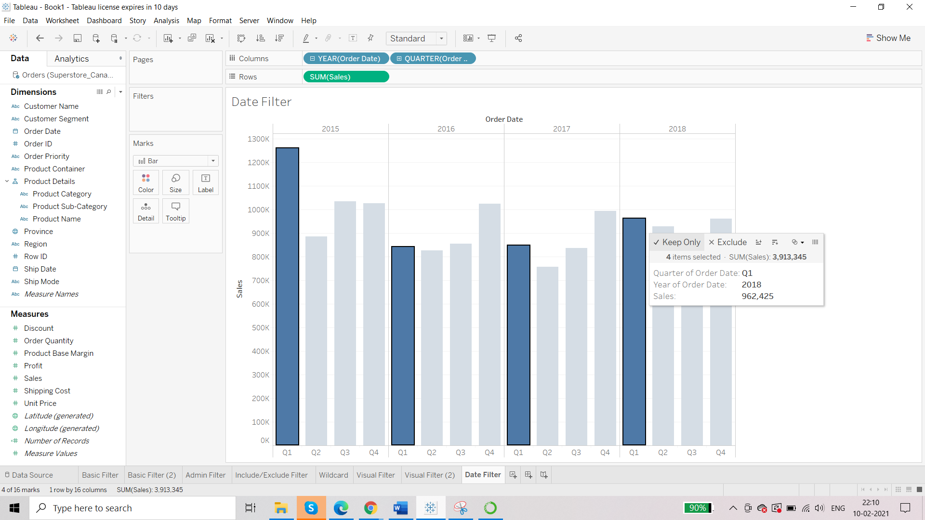

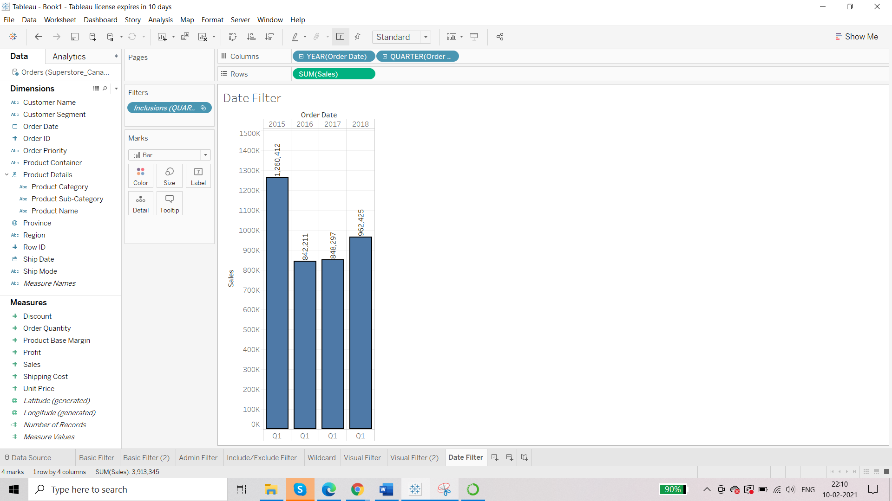

Approach 2: Drag order date to Filter Shelf

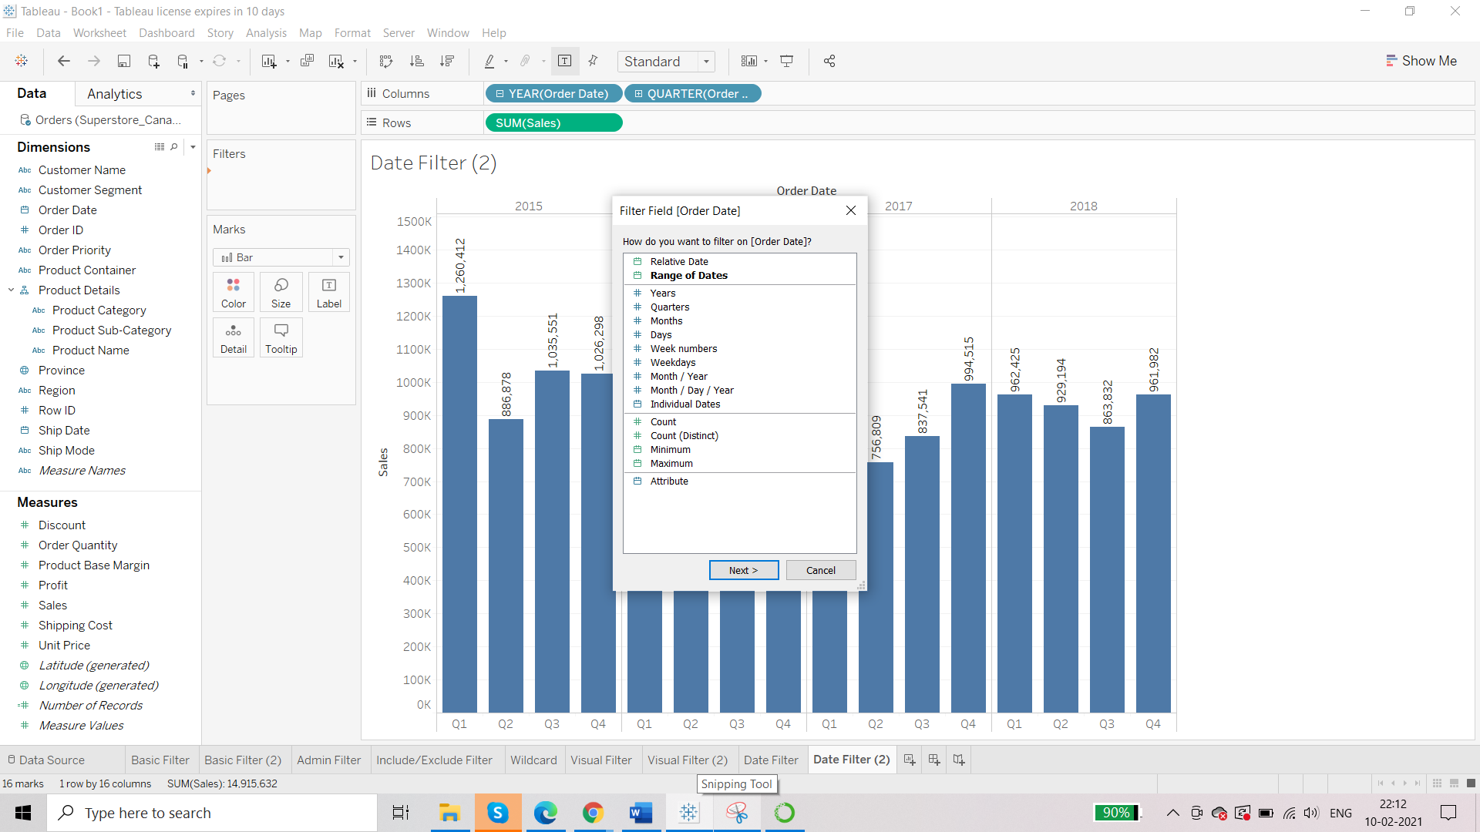

Apply for Years and then for Quarters.

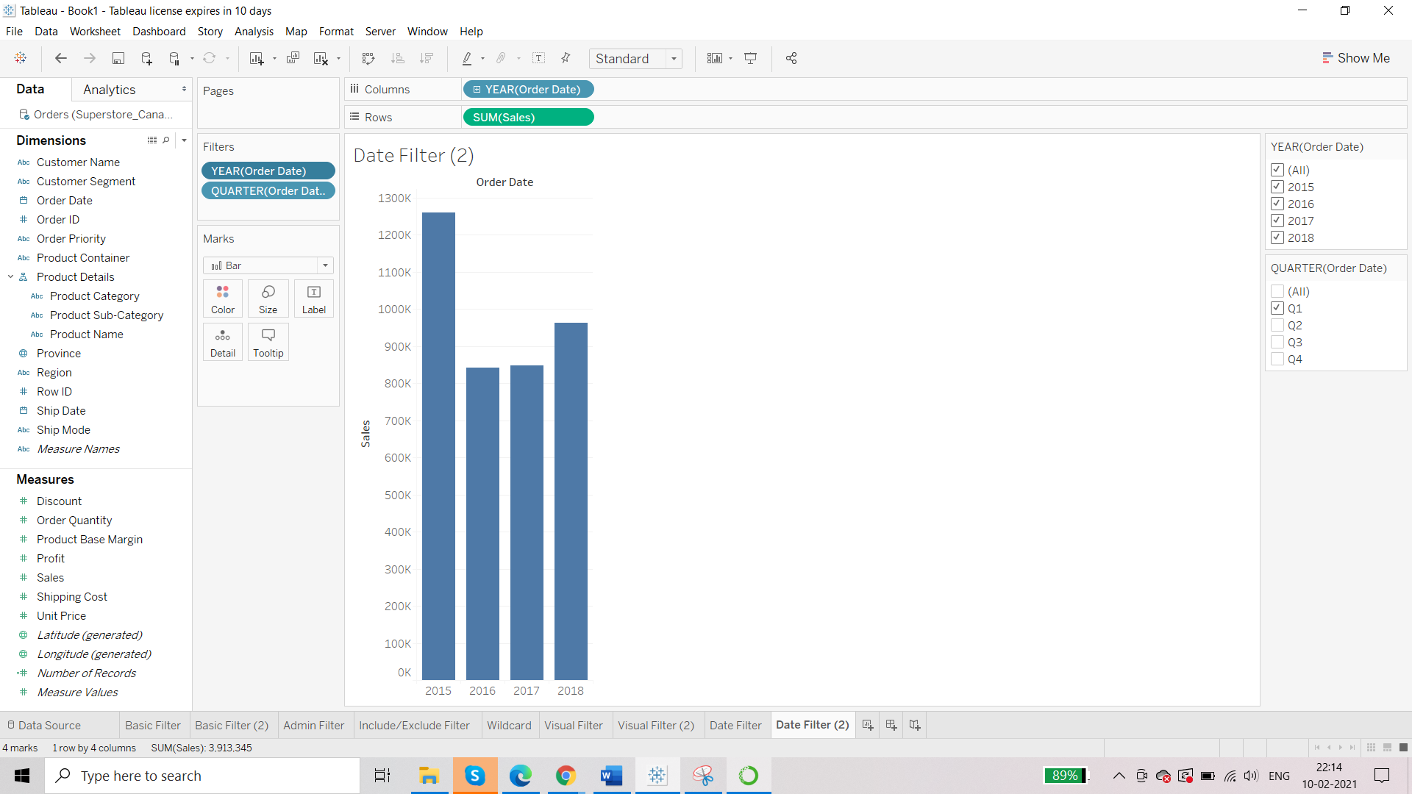

Range of dates:

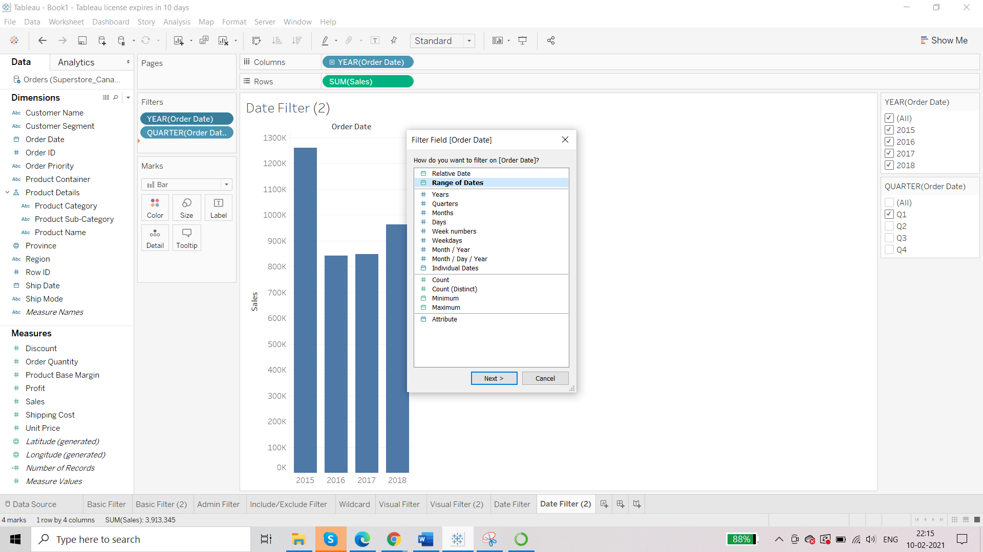

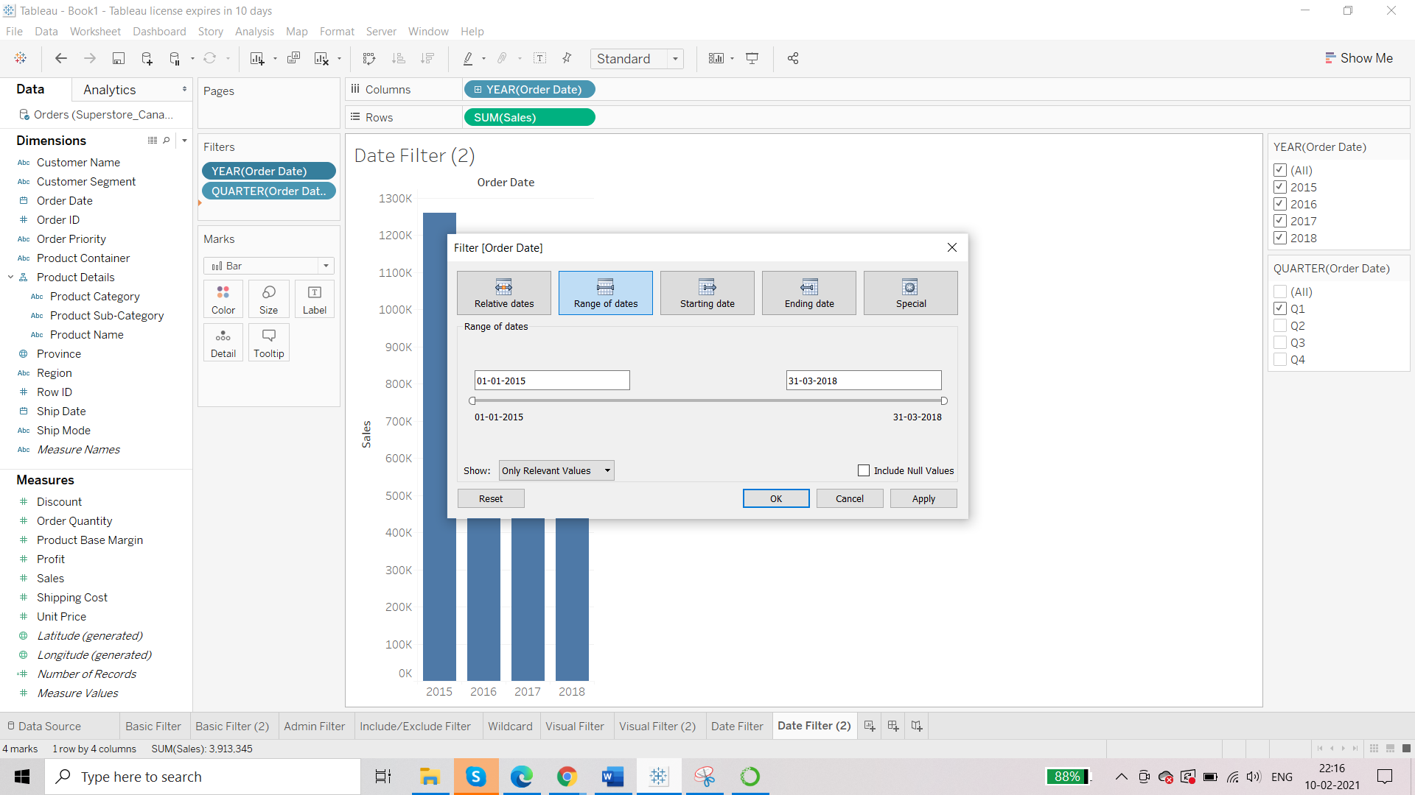

Filter Slider is available now:

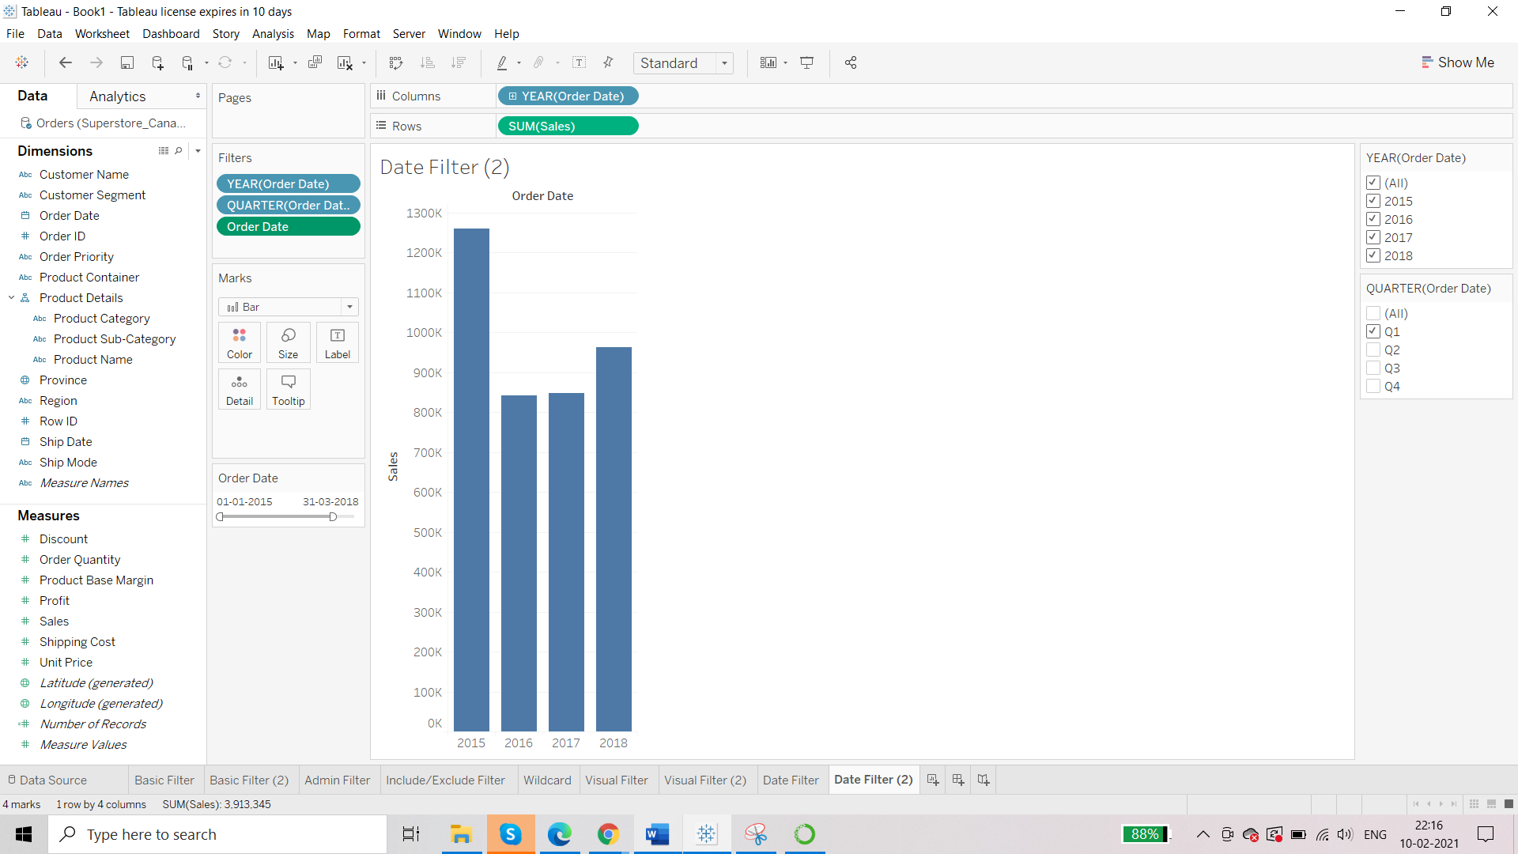

You can use Relative dates too.